**Learning Objectives**

By the end of this module, you will be able to:

* Define software testing and testing life cycle.
* Describe different types and ways of testing software.
* Explain robotic testing and low code automation.

**Glossary**

Here we have defined some of the terms you may come across when getting along with the module. Let’s have a look. 👇🏻

* **Debugging:**Debugging is the process of removing known errors from software programs and applications.

* **Test Coverage:**Test coverage is a metric that determines how many measures and aspects have been covered for validation during the test execution process.

* **Testing Life Cycle:**Testing Life Cycle is a sequence of actions that is performed while testing the software quality. It involves orderly activity that defines what your product intends to accomplish.

* **Automation:** In simple terms, technology that reduces human intervention is automation.

* **﻿Software Component:**A software item that can be tested independently without combining with other elements.

*Find more definitions of any Copado term in the*[*Glossary of Terms article*](https://docs.copado.com/article/s13ocfrvae-glossary-of-terms)*.*

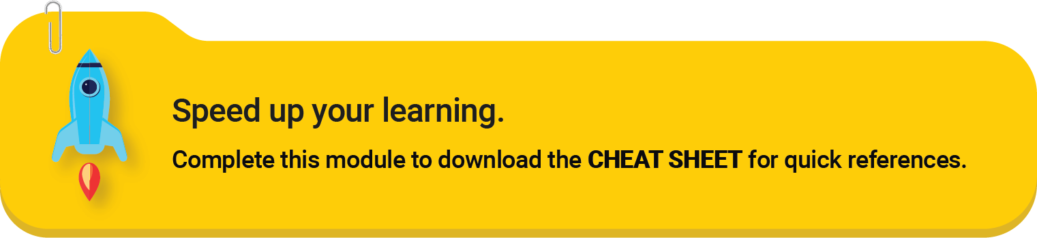

**Overview**

Today’s business model has grown beyond traditional methods. Nowadays, enterprises look to develop full-fledged software programs and applications that would help their customers keep in line with the company’s products and services.

Smart-end software programs and applications are making businesses widely accessible and, at the same time, increasing customer engagement. However, developing software is not as easy as it looks. Software development is a rigorous process and so is analyzing that your final product is flawless and functioning as expected.

That is exactly what software testing is for. Testing enables you to identify issues with your software or application and verify if your final product does what it is supposed to. If you look forward to delivering the best possible product to your customers, effective and efficient testing is non-negotiable.

In this module, we will be discussing the testing lifecycle, how to perform a detailed evaluation of a particular application or software and why testing your product is that important. 👍🏻

**﻿Define Testing**

In layman’s terms, testing can be defined as a process to assess **how well your application works** and to ensure it meets all the requirements. It is like validating each and every step of your math equation so that you can know at which step it went wrong, fix them and make the equation work.

Testing is one of the crucial steps of the software development cycle that enables developers to draw comparisons between the product’s actual and expected outcome. Successful testing can be accomplished by proper planning and execution.

Creating a comprehensive strategy and a detailed roadmap can lead your product to meet business and customer requirements. Therefore, if you are eyeing to achieve maximum efficiency through testing, it is important to remember when and how to start testing your product.

**Importance of Testing in Software Development**

*Why does testing matter? What value does it bring for your product?*

To understand the significance of testing in a Software development cycle, let’s read the story of James.

**Case:**James is an entrepreneur who has a million-dollar banking app idea that will bring everyday financial activities to the fingertips of users and make it hassle-free for them. He hires an experienced team of developers and discusses the implementation plan for his app.

The team of developers roadmaps the entire process and finishes developing the app. The app is now ready for testing. James organizes a meeting and finalizes the testing strategy with a team of experienced QA analysts who will execute tests one by one in an individual manner.

**Action:**James initially decided to test his application holistically to ensure there are no hidden kinks in his first-ever about-to-be-launched product. However, as the app’s release date approaches, he realizes not all quality attributes could possibly be evaluated within the given timeline and he does not want to extend the launch date either.

Therefore, he eventually decides to abandon the idea of putting his app to holistic testing and briefs the testing team to only test the user interface and some core functionalities.

**Result:** Soon after the launch of the app, James finds out that the app has some usability defects due to which some of the validation fields in the app are not working as expected. This resulted in a large number of users abandoning the app.

James' excellent app idea sank because he overlooked the holistic approach of testing his app. Don’t be like James.

Reasons Why You Should Test Your Application

Every phase of software testing is crucial. Therefore, finding bugs and fixing them before the product reaches the users is imperative. There are many reasons to test your software or application before you release it to production. Here we are calling out some major ones. You need testing so that you can:

**Meet Your Business and Customer Requirements**

Your product should always best serve its users and to achieve that, adhering to the development lifecycle is more important than anything. When you carry out a test, you identify where your application fails to meet actual requirements. This enables you to deliver a product that meets customer and business expectations.

**Ensure Security and Avoid Unwanted Leaks**

As cases of frequent security breaches and malicious attacks in software applications keep growing, safeguarding tools and software has become the topmost concern for businesses. As a software tester, you have a great responsibility to prevent the business applications from certain risks by testing their security mechanisms to the fullest.

The security testing helps spot vulnerabilities in the product allowing the development team to proactively react and make the product resilient so that users would not have to worry about security risks. Also, improper testing could lead to the disclosure of defects to the end-users which is not good for the company’s reputation.

**Identify Product Adaptability**

You want your product to meet the users’ requirements, business needs and solve problems. Testing will help you accomplish all your business goals efficiently. Testing not only enables you to ensure the quality of the software, but also corroborates the product’s viability.

There are plenty of practices to know how compliant and satisfactory your product is for the user. If you think your final product has not turned out as what you supposed it to be, you can always embark on innovative testing strategies and make your application or software fulfill its intended function.

**Optimize the Application Functionality**

In case you find out that something is wrong with your product and it is not functioning the way you hoped it would, you can simply discuss the scenarios and fix points with your developers and QA team.

However, it is better to be in sync with your development team so that you can help them resolve the issues and errors parallelly. Meanwhile, they can keep up with their testing process for other functionalities and components of the product.

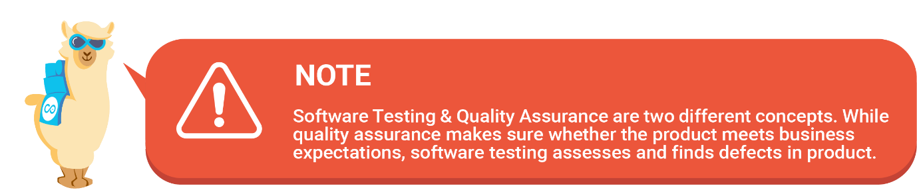

**Explaining Software Testing Life Cycle**

When it comes to putting the software, applications, or in some cases products and processes from the business side to test, it is always better to start in the early stage.

The team of developers usually prefers to indulge in assessing the design and other requirements of software during the development stage. Analyzing and fixing issues in advance saves time and allows you to exceed the usability expectations of your customers.

To save users from having a bug-filled experience with a product, it is recommended to carry out a well-defined strategy that clearly explains the activities to perform in each phase during the testing process. With that said, given are the five stages of the **Software Testing Life Cycle (STLC)**.

**STAGE 1 - Gathering Requirements**

This is considered to be the first stage of the software testing process where the team of testers understands the requirements of the product and what they want to achieve with it.

In this stage, the team of quality assurance and testers pay heed to the more specific details about the product and generate test feasibility reports.

**STAGE 2 - Test Planning**

Now comes the second stage, which is entirely focused on planning. Here the team creates the test plan that is often formed by the QA team after analyzing all the necessary testing requirements.

Test planning is triggered along with the test managers and other members who are going to be part of the testing process.

Test planning is detailed documentation about test strategy, objectives, deadlines, and resources.

**STAGE 3 - Setting up the Test Environment**

Once the requirement analysis and planning are done, it is time for the testing team to set up an environment where your test cases can be conditioned to undergo a series of experiments.

Once the environment is created, it needs to be maintained and must meet minimum requirements for your test instructions to function.

There are different kinds of environments you can configure, such as creating an environment on the test server, local builds, etc. This is one of the crucial steps in the testing life cycle.

**STAGE 4 - Executing Tests**

Now your application is ready for testing. This is the major part where the team performs testing and zeros in on monitoring the test behavior and identifying and logging the defects.

The team, at this stage, will also be accountable for running the test cases and comparing the actual test outcomes with what they expected.

If bugs are detected, the product will go to the development team so that they can remove bugs and the whole product will be tested again to ensure that everything is working as expected.

**STAGE 5 - Completing Testing Procedures (FINAL STAGE)**

This is the last stage of the STLC. As the name suggests, this is where the testing process will be marked as completed and closed.

Once the test execution step is completed, the team comes together and discusses and shares their experience regarding the testing.

The team of testers produces a document that gives a summary of all the bugs removed and issues found.

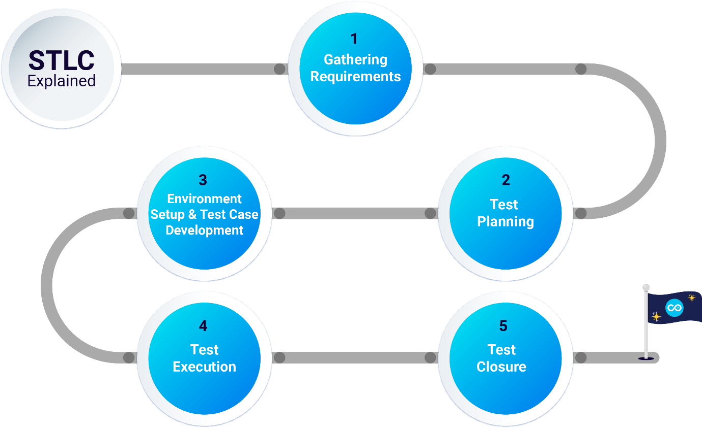

Software development projects are divided into different parts and the quality of each segment is evaluated by the team of quality and testing professionals assigned to each project. However, the involvement of additional professionals during the software testing also depends upon the nature of testing being conducted.

In general, the testing is carried out by - QA Analysts, Test Engineers, Test Analysts, Software Testers, Quality Assurance, Developers, Test Managers, and Performance Testers.

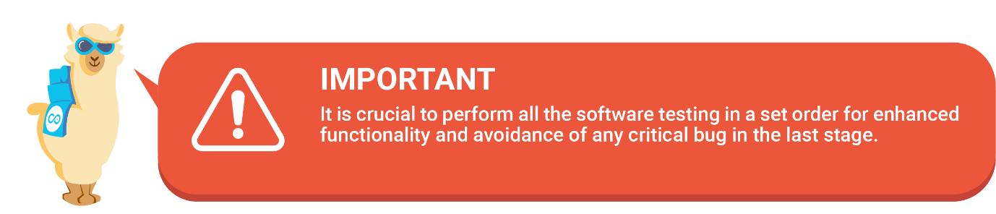

Done!

**Overview**

So far we have learned the importance of testing in the Software Development Life Cycle and how each testing stage plays a vital role in making your software program or application a successful product.

In the upcoming topics, we will discuss two different approaches to test your software and review the different types of testing.

It is important to decide on the testing method and type before getting into the testing process. Why so? Determining different testing phases helps the testing team engage in the test execution process in the most dynamic way possible.

Just as testing methods, testing types are formulated to identify gaps in features or functionality that prevent the programs or their components from achieving expected results and reconcile all the units of testing.

﻿However, the testing types cannot be applied abruptly and must be decided as per the nature and objectives of test cases.

**Manual Testing vs Automated Testing**

There are two approaches to testing your software products - **Manual or Automated**.

**Manual Testing**

As the name suggests, manual testing is where a Quality Analyst or testing team runs tests manually to identify bugs and errors in software programs or applications. That means, carrying out manual testing does not require automated tools.

Let’s understand manual testing using an example. A developer has created a food delivery app that allows customers to place food orders on a single tap. To test the app’s functionality and features, the tester steps into the end-user’s shoes and carefully examines every element of the program. While doing so, it finds out that the *Track Order* button in the app does not redirect customers to the food tracking page. It then reports the bug to the developer.

In this example, you see that the tester became the end-user, delicately executed the steps, and validated if all the features are working as expected. These tasks were performed by the tester manually without any tools.

**Automated Testing**

Automated testing is also known as test automation, in which the software testing is performed using automated tools. The majority of businesses nowadays prefer automated testing as it draws higher accuracy in test results, speeds up software delivery and provides improved bug detection capabilities.

Test automation brings faster validation. The concept of automated testing has advanced so much that many test automation tools do not require test scripts to run the steps as they enable testing with minimal or low code test scripting. This means even those who have minimal or no experience in testing can carry out testing easily.

﻿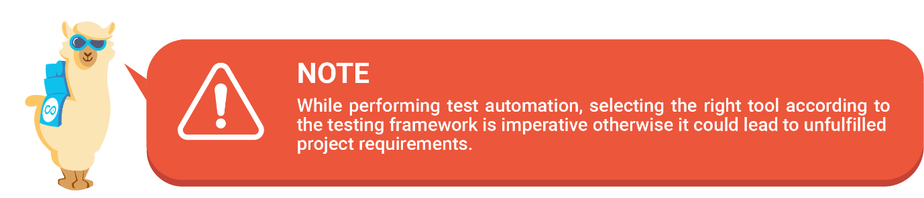

**Functional and Non-functional Testing**

Since we have discussed two different testing approaches, let’s now take a look at the testing types. There are two software testing types that conform to the business needs and customer requirements.

These testing types are - *Functional and Non-functional*.

Let’s discuss in detail about these two testing types along with the certain differences they share.

**Functional testing**

When it comes to assessing whether the product is working right for the purpose it was made and confirming that a set of features are up and running, the concept of functional testing behavior becomes important.

Let’s suppose you have to check how the particular component in a software program works and benefits users, you will need to execute functional testing.

While performing functional testing, the major objective of the Quality Analysts and testing team is to verify if every aspect of the application is in alignment with the prescribed requirements and use cases.

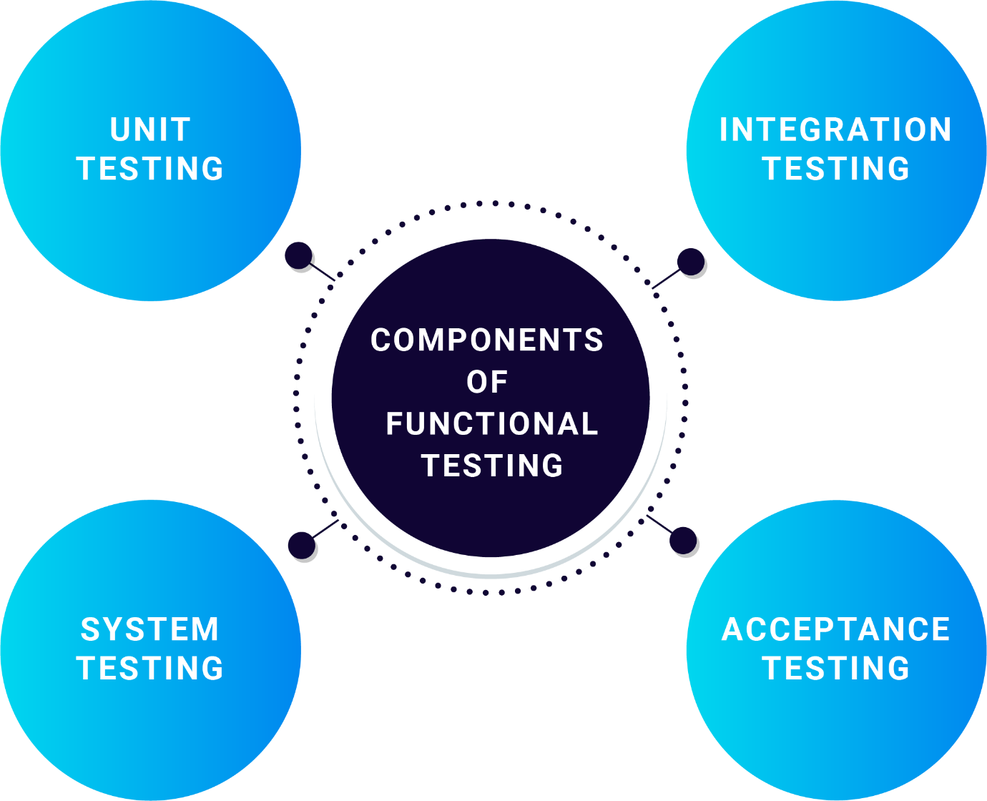

**Non-functional testing**

On the other hand, non-functional testing is a type of testing that evaluates the performance, usability, and reliability of the software.

So when it comes to verifying if the behavior of your product is as per the users and business requirements or not, you bring non-functional testing into being.

The testing team checks all the aspects not covered in functional tests in non-functional testing. Like functional testing, non-functional testing comprises four vital testing components i.e. - **Performance, Security, Usability and Compatibility.**

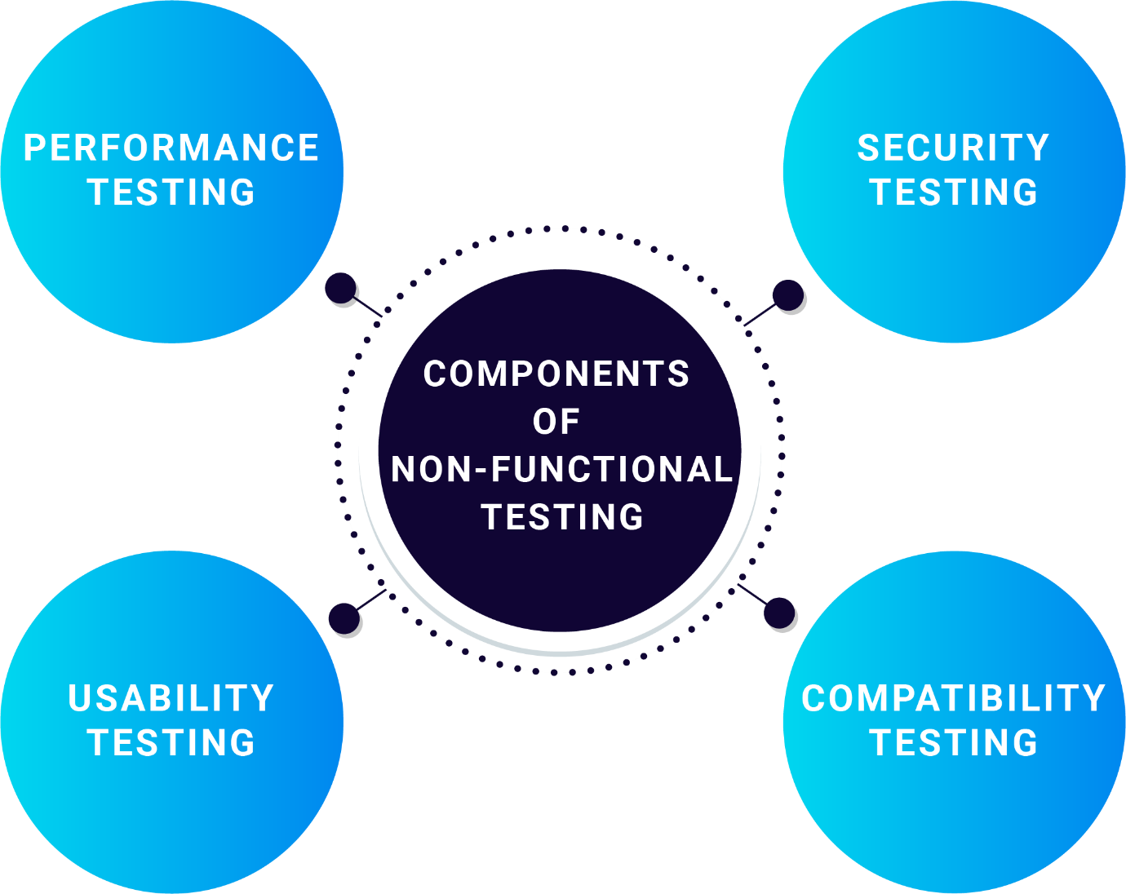

If you have to understand the basic difference between functional and non-functional testing, you can say that functional testing explains the behavior of the software while non-functional describes the overall performance of the software.

**Understand Test Process with Use Case**

Do you still remember James who launched the poorly-tested app in the market and failed to achieve remarkable success? In the following test case scenario, we will see how he learned the importance of testing the product holistically and finally managed to start anew.

**Case:**James 👨‍💼 realized his app failed in the market due to improper conduct of testing. He now wants to save the day by being well organized and relaunching his app.

**Action:** James figured out that manual testing wasn’t cutting it, not only because of its tedious nature but also because manual tests are limited in scope and number of functionalities that can be tested within a designated period of time. Therefore, this time James wanted to try his luck with automated testing that enterprises across the globe are widely using.

He spent time discovering an ideal user-friendly test automation tool that would provide him with more flexibility when it comes to putting each component to evaluation with a different configuration.

After conducting careful research, James finally managed to find an end-to-end test automation tool that comes with advanced scripting capabilities and requires very low human intervention.

James believes that this is the tool that will be very helpful in performing an absolute testing operation for his banking application.

**Solution:** James, with the help of an experienced team of testers, put his app to evaluation. Using the test automation solution, the testing team followed through the testing lifecycle and stumbled upon potential vulnerabilities where validation fields were not working properly for users.

This time James did not have to wait longer for the test completion nor did he have to compromise with the approach of evaluating his app comprehensively.

﻿After completing the testing process, the team provided a detailed bug report to the development team. The developers dug deeper and managed to make the app bug-free. 😀

Done!

Before going any further, let’s recap what you have learned so far.

In previous units, you learned about testing, how important it is to put your product through an evaluation before the final launch, and how the testing team chooses between different testing types while running quality checks for a product.

Good 👍🏻! Now, let’s explore this unit to get the grasp of new-age testing and what else the testing ecosystem has lined up for you.

﻿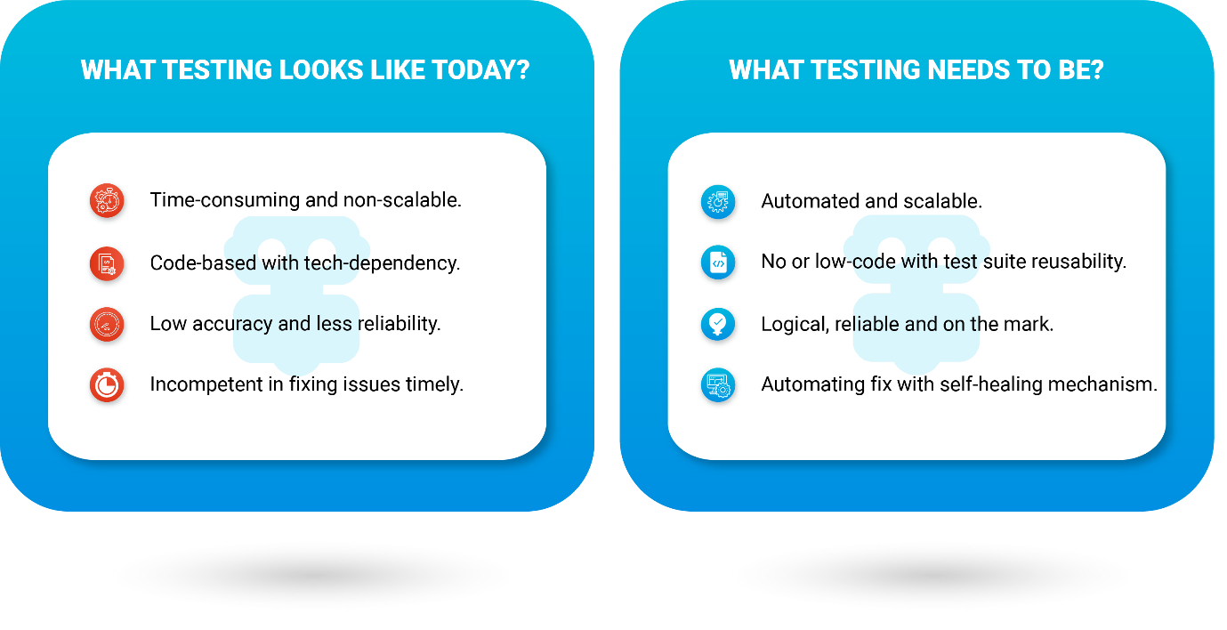

**Introduction to Robotic Testing**

What comes to your mind when you hear the word Robot 🤖? If this question was asked decades ago, you would see people responding about movies they have watched where machine-like humans are making an appearance or their kids are growing fond of remote-controlled toys that replicate humans.

Fast forward to today, the answers from the new-age generation could be interesting and subjective such as using AI-driven virtual assistants to play their favorite song, or having robotic vacuum cleaners save them from day-to-day household cleaning chores.

In the current era, robots resemble smart and automated devices that are being used in every single industry. With that said, there is a new concept that has been rolling around in the testing landscape - **Robotic Testing**.

Robotic testing is one of the modern methods of assessing how individual programming structures of software function with minimal or no code. The major objective of robotic testing is to make the software testing process smarter and more efficient. Therefore, the implementation of Artificial Intelligence and Machine Learning during the testing life cycle gives rise to next-generation test automation.

This means those who possess no or nominal experience with testing can perform the quality checks of their product with ease while not compromising excellence. Since robotic testing corresponds to automated testing in some way, you can refer to robotic testing as the progressive version of the test automation method.

Now, businesses historically under the immense pressure of delivering high-quality products to their customers with complex testing demands can heave a sigh of relief with the revolutionary robotic testing approach.

Let’s deep dive into the world of Robotic Testing and understand its working practices. 👍🏻

**Importance of Robotic Testing**

Now you know what Robotic Testing actually is, you may be wondering how this fragment of the testing space is going to revolutionize the whole quality assurance and testing space.

Here we have discovered some algorithms that win over any other testing method. By including a robotic testing method in your testing life cycle, you will be able to:

**🚀 Achieve quick and efficient test results**

When it comes to running manual testing, there are several pitfalls that sometimes are not easy to determine by the team, such as which component among many in a business process is failing as a part of the test execution. With AI-integrated testing, the product can be put to test and can be evaluated in a matter of minutes. The reason why robotic testing is gaining momentum among many businesses is that it enables you to execute tests rapidly and consequently deliver value to your end-users faster.

**⏱️Real-time self-healing attribute**

Self-healing is a new concept in the test automation ecosystem that identifies the issues in existing test cases and provides an intuitive and automated fix to ensure that your test case is up and functional. The process of detecting issues and activating healing is pretty simple. Self heal feature detects the mismatch or disrupting steps in the test case. By selecting this option, the team can to implement the suggested correction and heal the test step in real time.

**✅ Run detailed results for complex test components**

Though there are many reasons why robotic testing is worth the investment, reducing the chance of human-error while running complex test cases is a major one. When manual testing is performed, it involves trying various use cases and scenarios where the testers need to record behaviors all by themselves. On the other hand, robotic testing improves accuracy and records detailed results for complex test cases automatically.

**⚙️ Perform predictive analysis using AI**

Artificial intelligence turns out to be a key factor in robotic testing. Apart from making testing smart and efficient, AI applies reasoning and problem-solving approaches to automate testing, which is why it becomes easy to put the data-driven testing methods into action. Historically, test automation lacked this feature as it does not entirely consider performing the steps based on new-age smart methodologies but that is not the case with robotic testing.

**What Kind of Test Cases Can Be Run via the Robotic Testing Approach?**

As you know, robotic testing lets you define testing tasks at your convenience and then takes over the execution of test cases for you, but are all test cases ideal to be performed via robotic testing? Not exactly.

Not all types of tests are suitable for robotic automation. Test cases require a robotic testing approach only if:

* They are highly repetitive in nature and take extensive time to perform manually.
* The cases and components are likely to cause a human error as it involves a lot of complex units.
* The test case is critical in nature and cannot be compromised with the quality.

**Robotic Testing and DevOps**

Before getting further into defining the relationship between Robotic testing and DevOps, let’s first know about DevOps in general. As you see, DevOps is the word coined by combining **Development** and **Operations**.

This is a set of practices that brings people and technology together during the software delivery lifecycle. In other words, DevOps empowers the process, culture, and aspires to improve collaboration between cross-functional teams.

The concept of robotic testing is proving to be a phenomenal trend that is immensely driving the software testing ecosystem. On top of that, the integration of DevOps practice in it is seemingly amplifying the delivery of software projects in which both the development and operations teams work together.

If combining development and operations culture adds to productivity, implementing varied automated tools in the DevOps environment lets organizations harness impressive results.

**Let’s understand the importance of applying DevOps best practices to testing with an example.**

**Case:**Stuart 🧑🏻‍💻, who is a release manager, is reviewing all the changes introduced by the team of developers so that he can promote them to production.

While doing so, he stumbled upon a line of code that was not functioning as expected. He wondered if this particular code structure was overlooked while getting tested.

**Action:**Since Stuart has been using DevOps methodology, he knows that his team follows a continuous development practice where the code is written and committed using Version Control.

**Solution:**This allowed him to identify at which line of code the issue was and instead of creating conflict for the entire chain of development, he instead asked the development team to work on that code structure particularly to meet high-quality deliverables.

Once the development part is completed, the testing team is ready to perform end-to-end testing by implementing automation tools so that the elements can be tested quickly and the team can meet the deadline.

Both the teams were aware of each other’s progress, which is why it was possible for Stuart to meet deliverables on time.

Done!

**Low Code Test Automation and Its Benefits**

So far, you have managed to understand the supremacy of robotic testing and how beneficial it has proven to be when it comes to finding software defects and fixing the same in real-time with leading age automated tools.

But how can robotic testing be more progressive so that the advanced test automation process can be more effective than before? Well, for that a low code scripting syntax has been introduced.

The low code testing approach gives heads-up to the robotic testing process and advances towards taking the entire testing ecosystem by storm.

The basic concept of a low code testing approach is to allow all testing professionals to create, run and manage test cases, regardless of whether or not they have traditional coding experience.

The key to a low code testing approach is to either assemble libraries of scripts in your test environment to execute commonly repeatable tests or to use natural language commands such as ClickText **Sales** or VerifyText **Accounts**.

project

﻿

[](https://copado.my.salesforce.com/sfc/p/#b0000000YN5R/a/5p0000019yMO/69h8G6PaspJDqJuEtgzwlwFCNkn.rfkxSfAiSlV89iU)

*Well done! You have reached the end of this module. We hope you had a great time learning about****Software Testing Fundamentals****. You can now go ahead and take the quiz to add a new shiny badge 🏅 to your achievements. Good luck!*

Done!

**Learning Objectives**

By the end of this module, you will be able to:

* Define what Copado Robotic Testing is and its benefits.
* Identify important components of Copado Robotic Testing.
* Set up a Copado Robotic Testing account and perform testing.

[](https://success.copado.com/s/learning-plan-detail-standard?ltui__urlRecordId=a975p000001UK3iAAG&ltui__urlRedirect=learning-plan-detail-standard)

**Glossary**

Before starting your learning journey, help yourself with some tricky words used throughout this module. 🤓

* **DevOps:**A practice of encouraging collaborations between software development and IT operations in an enterprise.

* **Test case:**In software testing, a test case is a digital document disclosing a set of instructions or steps to be executed during the testing life-cycle.

* **CI/CD:**CI stands for continuous integration while CD means continuous delivery. This is one of the modern DevOps practices implemented by the development and operations team across businesses.

* **Software Repository:** A digital storage location where software packages are stored.

* **Git:** A cloud-based version control management system that allows teams to collaborate on various projects and tasks.

*Find more definitions of any Copado term in the*[*Glossary of Terms article*](https://docs.copado.com/article/s13ocfrvae-glossary-of-terms)*.*



**Overview**

The technology, up until now, has progressed at warp speed. Nowadays, you do not require expert coding skills or have to familiarize yourself with widely popular programming languages to begin your testing journey.

However, in order to begin with the testing process, getting a holistic understanding of the testing mechanism is important.

Manual testing is indeed the easiest way to test your software functionalities and know how viable your product is. However, it could be time-consuming sometimes.

This is why we, at Copado, believe in implementing the groundbreaking concept of test automation to make the testing exciting and a less daunting process for everyone. The idea behind developing Copado Robotic Testing is no different.

**What is Copado Robotic Testing?**

Copado Robotic Testing (CRT) is an AI-implemented test automation solution that enables you to create and run test cases in minutes. CRT provides you with ready-to-deploy test infrastructure in the cloud.

It takes the complexity out of setting up and maintaining a sophisticated testing environment. As CRT is a cross-platform automation tool, you can run test cases on the web, mobile, and native desktop operating systems. CRT is designed to work for both low and pro coders. Using QWords, CRT allows you to create test cases with a handful of simple commands.

*In this module, we will wade deeper into understanding the Copado Robotic Testing tool as a problem solver for businesses.*

**Features of Copado Robotic Testing**

*Why make testing boring and mundane when it can be super fun?*😀

Copado Robotic Testing is embarking on a journey to revolutionize the testing ecosystem as a whole. It takes the complexity out of setting up and maintaining a sophisticated testing environment and provides users with flexible AI-enabled test automation infrastructure.

Putting forward a low or no-code testing concept, Copado Robotic Testing turns out to be an extremely productive solution for businesses looking for executing easy and effective test automation.

Let’s explore some highlights of the solution so that you can understand how it makes the most sense for your business.

↔️ **Cross-Platform Automation With End-to-End (E2E) Testing**

With Copado Robotic Testing, you can automate testing for hybrid environments. That means you can evaluate and verify the test steps on the web, mobile, or native desktop operating system. Its intelligent robotic testing feature enables you to see how the test cases function under live setting conditions.

Moreover, packed with essential features, the extensions let you test hardware in the loop, Android Automotive, AUTOSAR standards, etc.

☁️ **Multi-Platform and Cloud Reliance**

When it comes to test automation, platform requirements can present obstacles. Keeping this in mind, we developed Copado Robotic Testing in a way so that it grows beyond platform and cloud agnosticity.

With Copado Robotic Testing, we allow businesses to not be limited to a specific platform and rather widen their approach to multiple cloud-based platforms such as SAP, Salesforce, Oracle CX Cloud, and many others.

🗃️ **Built-in Project Template and Test Case Libraries**

To start evaluating business processes or individual applications with Copado Robotic Testing, you need a project.

However, you do not have to worry about any exhaustive configuration process as we have ready-made templates along with test case libraries and self-explanatory keywords (defining test cases using action words) that get you started in an instant. Also, you can modify the templates and keywords according to project preferences.

⏺️ **Live Testing and UI Recording**

At Copado, we focus on providing you with an out-and-out testing experience with limitless benefits. That is why we keep on scouting out-of-the-box ideas.

To be frank, this is how we stumbled upon introducing a live testing environment and visual test recorder feature that generates test scripts from actions you perform on the UI. Moreover, you also have recorded videos of live testing that are excellent means for fulfilling debugging purposes.

🔗 **Open API for Integrations and Scheduling of Test Cases**

One of the prominent features Copado Robotic Testing offers to you is triggering manual scheduling of tests. This feature is highly utilized for monitoring and visibility throughout the DevOps Team. Moreover, Copado Robotic Testing is also designed on open APIs to facilitate quicker integration with external sources.

Therefore, the Copado Robotic Testing platform allows you to send API calls from any CI/CD tool like Jenkins or Copado.

﻿

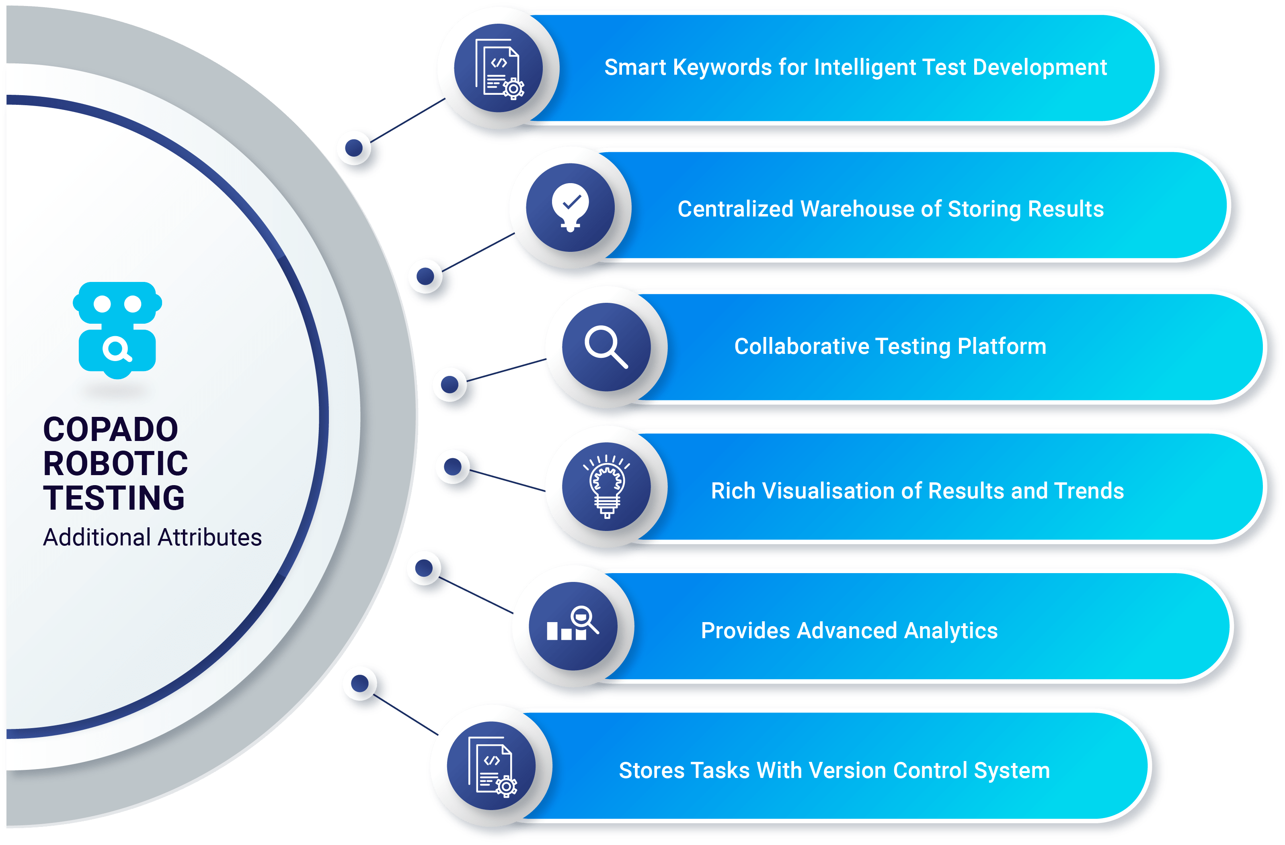

**Essential Components to Setup Test Infrastructure**

Now that you know what Copado Robotic Testing is and how rewarding it could turn out to be for your business, it is time to learn about the important components that have tuned the Copado Robotic Testing structure all the way.

**Project**

Projects are one of the most powerful management tools in Copado Robotic Testing. Your test automation journey in Copado Robotic Testing starts with creating a project.

Project lays the foundation for all the tasks you are going to follow through to run your first test. You can find the project on the top right corner of the Copado Robotic Testing page, however, projects can also be identified as a briefcase icon.

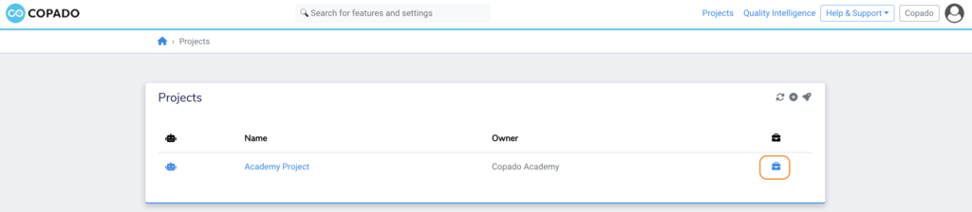

**Robots**

Robots are your test automation engines in the cloud**.**You can also understand robots as a digital workforce that gets everything ready for you before you run your tests including environment, test type, and other possible inbuilt capabilities. In Copado Robotic Testing, Robots can be identified as robot icons.

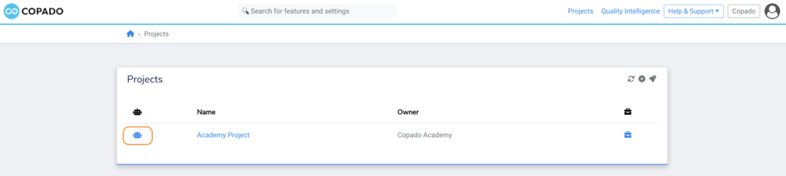

**Suites**

Suite is a component tied to Robots that carries all your test functionalities. You cannot perform testing without creating a suite.

In Copado Robotic Testing, you can either create an all-new suite from scratch, use pre-configured test cases or employ existing test scripts from a Git repository.

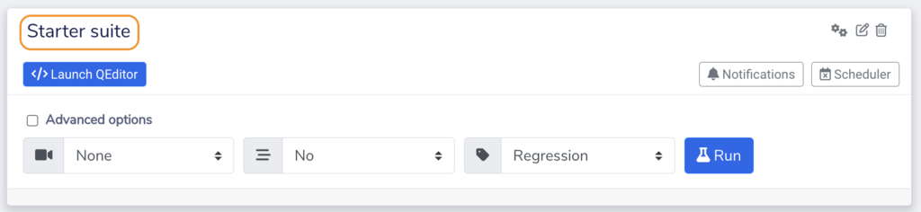

These are the three important components that you will be needed to set up your test infrastructure in the Copado Robotic Testing solution. There is another component that allows you to obtain insights on what you need to fix and improve from the perspective of the test run. That is**Quality Intelligence**. You can select different widget types for your Quality intelligence dashboard.

**Resources**

[*Copado Robotic Testing - Quick Guide*](https://docs.copado.com/articles/#!copado-robotic-testing-publication/quickstart)

**Login to Copado Robotic Testing Account**

Setting up a test environment in Copado Robotic Testing is simple and straightforward. Though there are many reasons that make the configuration simple, the platform agnosticity and pre-configured cloud-based concept are what make Copado Robotic Testing infrastructure stand out.

Copado Robotic Testing allows you to sign up for a personal plan, which includes access to limited features, or a business plan, which includes additional features of the solution.

* If you are signing for the business plan, you need to have a valid subscription from Copado or one of the suppliers your organization has created in Copado Robotic Testing such as Azure.

* If your organization uses Microsoft Azure AD authentication, you can log in with the same Microsoft business account credentials. Otherwise, Copado or the suppliers can provide you with separate user credentials.

Let us help you map out the Copado Robotic Testing account setup. Here are the steps to be followed:

1. Open the login **URL:**[**https://robotic.copado.com**](https://robotic.copado.com/)**.**
2. Select the correct **Region**(European Union or the United States).
3. Click on **Sign up** to create a new account.
4. Enter your details like Name, Enterprise email, passwords, etc.
5. Check your email for the verification link and verify your account.
6. Now login to the Copado Robotic Testing using verified credentials.

Well done! 👍🏻 You are now signed in to the Copado Robotic Testing where you can explore your dashboard and different sections.

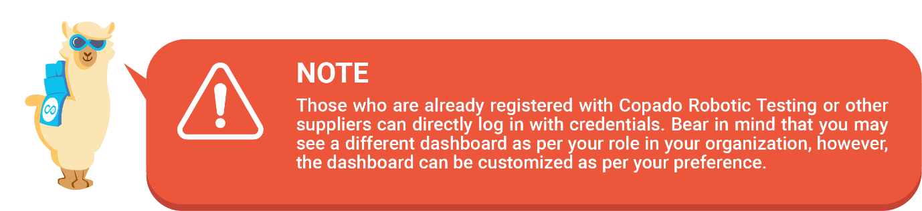

**What Does Each Segment on the Homepage Have to Offer?**

* **Example webshop card:**This is automated test execution functionality where you will have predefined testing conditions with a pre-built Project, Robot and Suite. You can modify the project, robot and suite to meet your testing needs. By clicking on next, your example test will be executed.

* **Your website card:** This section on the Copado Robotic Testing homepage enables you to create and run tests on any website of your choice. So let’s suppose you have no idea how the testing process works in Copado Robotic Testing, you can go ahead and follow through by running a test case on a dummy website. All you have to do is to replace the given test steps with your preferred ones.

* **Projects card:**This is the shortcut space from which you can select a project and related robots and suites. You can also manage and control all the elements related to your test from this segment.

* **Organization card:** The last card you will see on the Copado Robotic Testing homepage is organization. This is the user’s area of engagement where you will be able to see a list of actions that your organization can or cannot perform. Also, you can manage permissions and billing for users via the organization card.

**Creating & Configuring a Project**

In the previous unit, we have discussed a snippet of the project in Copado Robotic Testing and what role it plays in terms of organizing structure for test automation.

We’ll now wade a little deeper and see how you can create and configure the project and keep your AI-driven test automation infrastructure manageable.

In Copado Robotic Testing, projects come with access management wherein you can restrict who can view or edit a project. You also need to assign project level permission to your team so they can have appropriate access to it.

﻿Project keeps your organization's test automation efforts compliant. As per the team collaboration and business requirements, separate projects can be created and maintained.

So, are you ready to create your first project in Copado Robotic Testing? Let’s do it then.

1. Login to the Copado Robotic Testing platform.

2. From the homepage, navigate to the Projects card and select **View.** You can also click on the **Projects** section as you see in the upper-right corner of the screen.



3. You will then be redirected to the project page where you will be asked to create a new project. You can do so by clicking on the **+** icon.

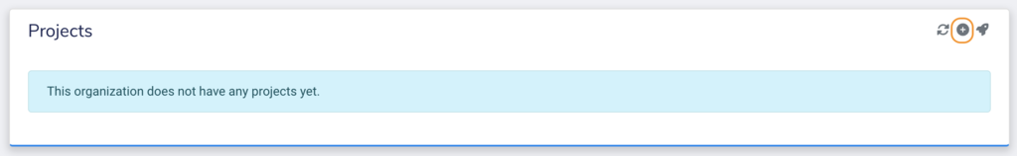

4. Next, you need to fill in some details such as project name, project type, and description and click on **Save**.

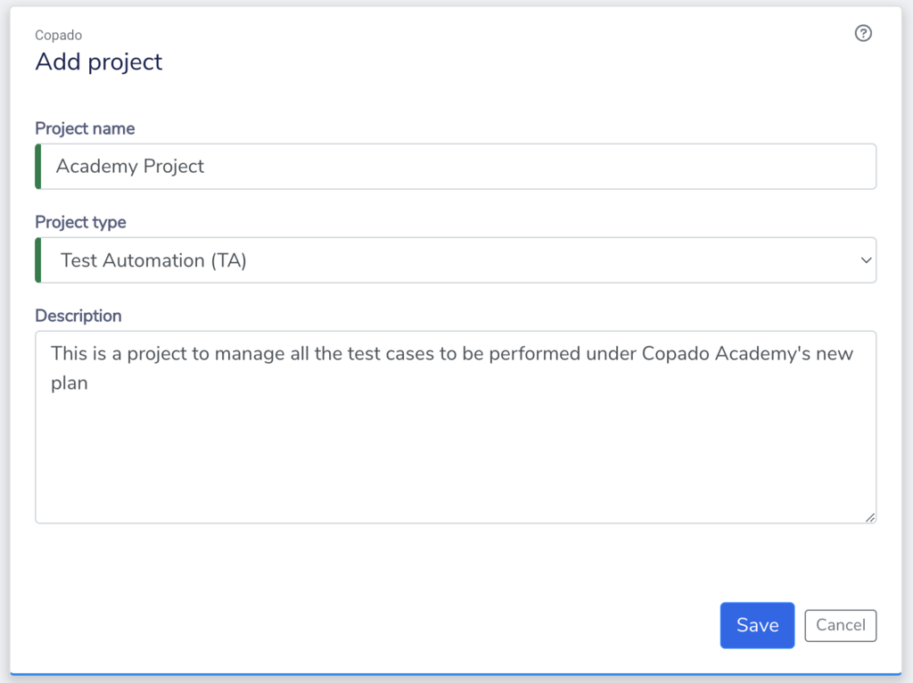

5. After clicking on **Save**, the project homepage will appear where you will see plenty of information about the project you have created such as project name, permissions you have assigned to the users to access this project, etc.

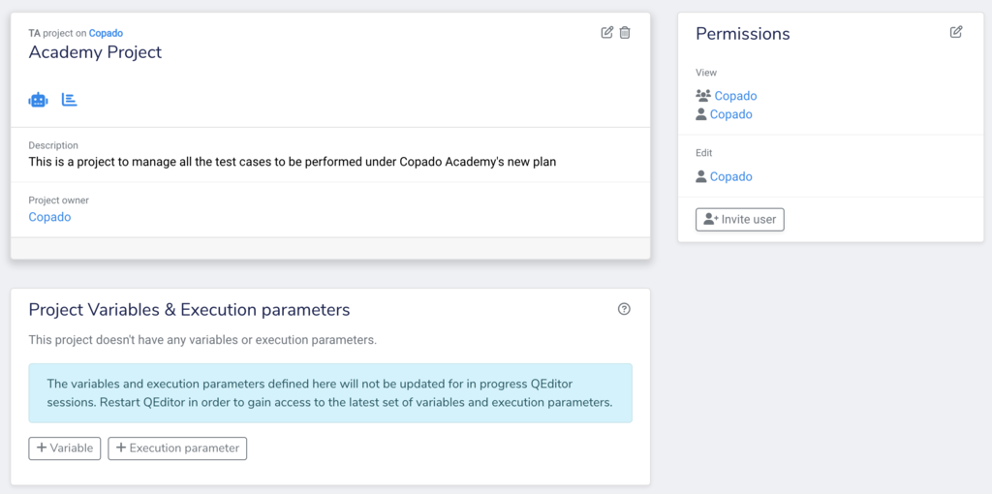

The permission restricts access to the project. A user or a group of users can be granted either viewing rights or editing rights to the project using permission. Permissions can be modified by clicking on the edit icon on the top-right of the permission box.

**Project Type Explained**

While creating a project, you will have the freedom of inspecting different project types such as Test Automation (TA), Robotic Process Automation (RPA) or Quality Intelligence (QI). Each of the project types serves a different purpose and has its own use and function.

Therefore, knowing the role and configuration of project types becomes imperative before you put them into line. Have a look at what each project type carries with them and what features you are likely or not likely to get.

* **Test Automation (TA):**If you choose this project type, you will have robots and dashboards enabled for your project.
* **Robotic Process Automation (RPA):**This project type will have robots and dashboards enabled but test runs streaming and recording will be disabled.
* **Quality Intelligence(QI):**With the selection of this project type, you will have dashboard enabled but you will see your robots disabled.

Test Automation is one of the widely used project types, however, you can choose one among the list appropriate to your project requirements.



**Deleting a Project**

Now there might be cases when the project you had been working upon all this while is over or due to any particular reason, you do not feel the need of having it anymore in your dashboard.

In that case, you can delete it by following the given steps. Although it is important to know that only the users holding the rights to edit the project can delete it.



1. Navigate to the **Projects page** and select the project you want to delete.

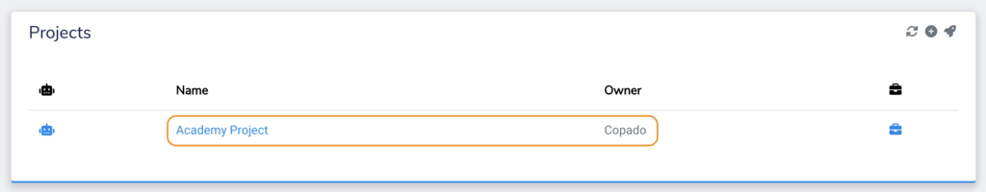

2. Click on the **trashcan**icon to delete the project.

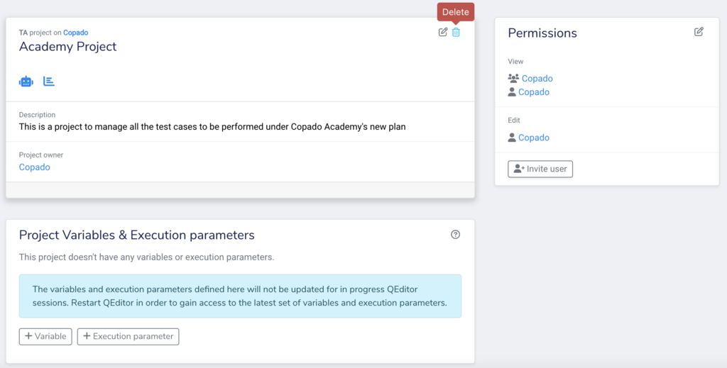

3. After clicking on the trashcan icon, a popup seeking confirmation will appear. You need to enter the correct project name and click on **OK** to continue with the deletion.

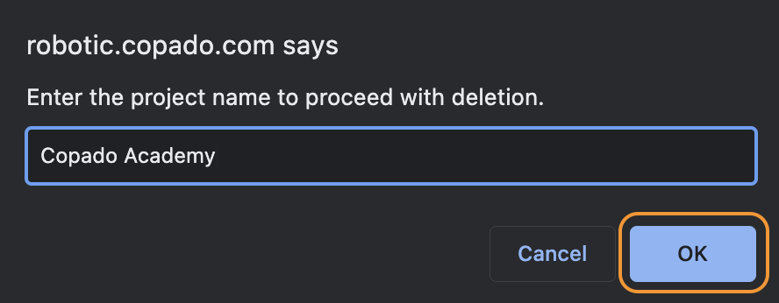

﻿



**Resources**

[*Copado Robotic Testing - Homepage*](https://docs.copado.com/articles/#!copado-robotic-testing-publication/homepage)

[*Projects Overview*](https://docs.copado.com/articles/#!copado-robotic-testing-publication/projects)

Done!

**An Overview to Robots**

Keeping up with an effective test automation strategy is not as easy as it sounds. From the business point of view, creating a robust test automation infrastructure may seem daunting. However, every task is problematic unless we have a solution to overcome it.

Copado Robotic Testing has robots that are programmed to understand test suites. Robots can be looked at as a new-age test executor that triggers test cases and generates associated logs and reports.

Robots are created inside a project and are only available for that project. Being one of the essential components of Copado Robotic Testing, Robots are capable of creating test automation infrastructure in a matter of seconds and can create and manage not just one but several test suites.

When you launch your project, you will see that your project’s quality intelligence dashboard is empty. It is because you have not assigned any robot to your project yet.

So what are we waiting for then, let’s go right ahead and kick-off the process of adding the first robot to your project.

**Steps to Add a Robot to Your Project**

Follow the given steps to allocate a robot to your project.

1. Go to your project page and click on **Add Robot.**

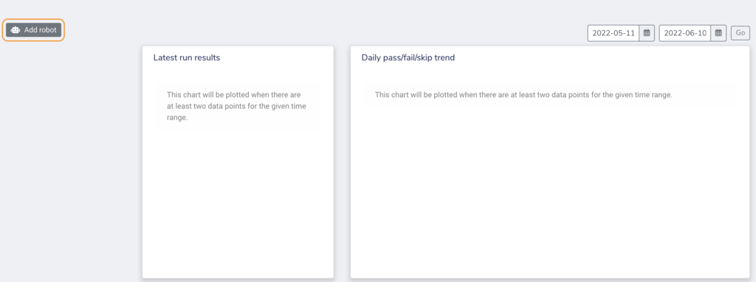

2. Fill in the required information such as Robot name, Robot Description, Run Environment, and Robot Type. Once done, click on **Save.**

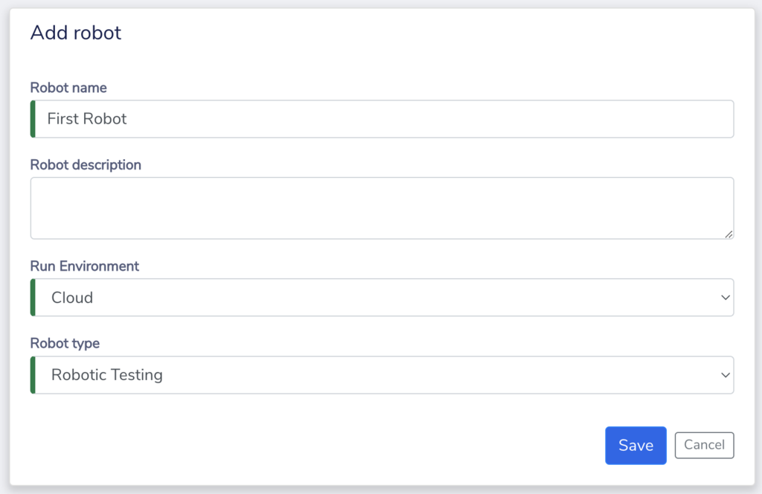

3. After saving the details, you will see that a robot has been added to your project. All the important information related to your project and robot can be located on your **Robot page/ dashboard**.

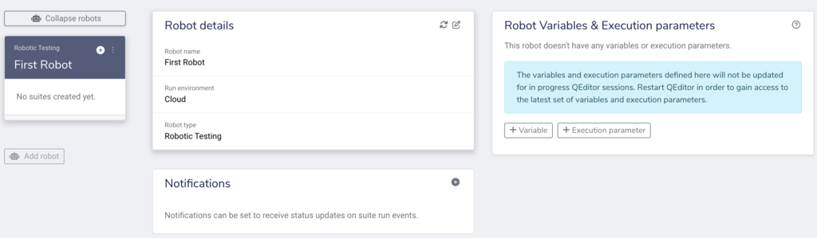

### **Run Environment and Robot Type Explained**

When you set up a robot for a dedicated project, you need to fill in the robot name and select relevant options for the Run Environment and Robot Type.

Choosing the right option between two considering your project could be confusing unless you know the purpose each field serves. So let’s know what the run environment and robot type in the robot dialog box mean.

**Run Environment**

As the name suggests, this field type illustrates what type of execution engines you want for your test automation.

Do you want your test infrastructure environment to be on cloud or on-premise behind a firewall?

Well, Copado Robotic Testing leverages you with both the functionalities complying with separate objectives to fulfill.

If you select the cloud option, you are basically deploying a full-fledged cloud-based robotic software testing solution. However, if you feel like having a robot that connects to the physical device, go for the QConnect option.

**Robot Type**

Once you have selected the environment, the Robot setup mechanism will ask you to choose the type of robot you want to create for the test automation execution. This option lets you choose the platform on which your application is hosted, either a website or mobile application.

A Robotic Testing robot type is used for testing web applications, however, if you wish to test a mobile application in a cloud device farm, you could select BrowserStack or BitBar service providers.

**Deleting a Robot**

If you want to delete a robot that you think is no longer required for a project, you can do so in just a matter of moments. Let’s follow through with the steps.



1. To delete a robot, navigate to your project and open the robot you want to delete.

2. Now click on the three dots you see on the robot and select **Delete.**

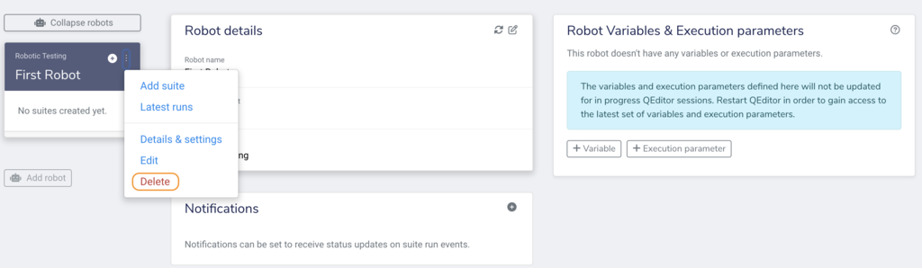

3. After that, a popup will appear seeking your confirmation for deletion.

4. Enter the Robot name and select **OK**.

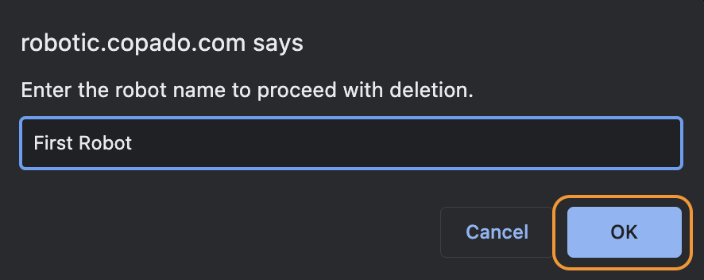

**Resources**

[Robots Overview](https://docs.copado.com/articles/#!copado-robotic-testing-publication/robots)

**Introduction to Suites**

In the world of CRT, a suite is referred to as a repository containing a set of test instructions that indicates how and what to perform as a part of testing. Let’s try to understand the role of suites in Robots with the previous analogy of Robots being test executors.

So as mentioned before, if your Robot is going to execute the test process from start to finish, it would need to understand what actions your test will perform. Suite in Copado Robotic Testing becomes that action. Suite divides your tests into several logical, smaller test processes that would be executed one after the other.

A suite cannot exist without a robot. When you execute tests in Copado Robotic Testing, you are actually running a suite that is linked with a Robot and that Robot is connected with a project. Your tests, results, videos, etc. are all tied to a suite.

Each robot can contain one or multiple test suites. Also, the created suites can be run manually, scheduled, and can even be triggered from external sources using Copado Robotic Testing API.

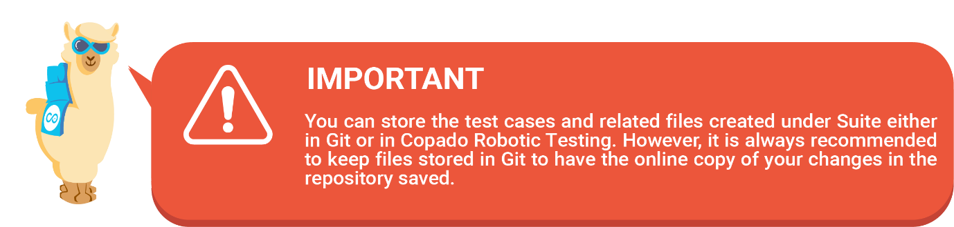

Now let’s see how you can create a suite for your robot that will execute your first set of test instructions. 😀

**Steps to Add a Suite to Robot**

1. Navigate to your project, locate your robot and then click on the **+ (Add Suite)** icon.

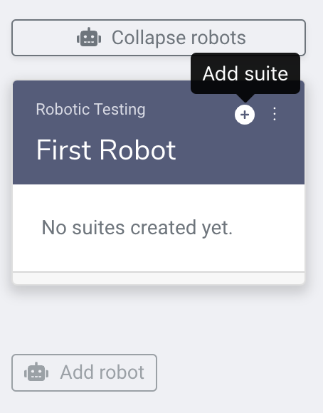﻿

2. Next, you will be presented with the different options of adding suites to your robot which are -

**a. Creating an empty suite:**This option will create a test suite without any pre-configured test scripts to execute. This type of suite has only one file pace.robot.

**b. Using predefined test suites:**With its predefined test suite, accelerator is a suite type that allows you to run tests in Copado Robotic Testing with a single click without setting anything up from scratch. This option includes test suites for Salesforce, ServiceNow, SAP, SAP S/4 HANA, and REST APIs as well. While using the Salesforce accelerator, you need to whitelist the IP address to pass by the Salesforce verification method. Here are the IP addresses you should be using:

i. For Copado Robotic Testing US instance - 75.101.241.39

ii. For Copado Robotic Testing EU instance - 52.212.32.52, 18.202.59.38, 18.203.104.35 (any one).

**d. Using an existing repository:**Another way to carry out a test suite is by linking your suite with a Git provider that has a maintainable test script to run. To add a suite with Git repository, you need to choose the provider and enter a personal access token.

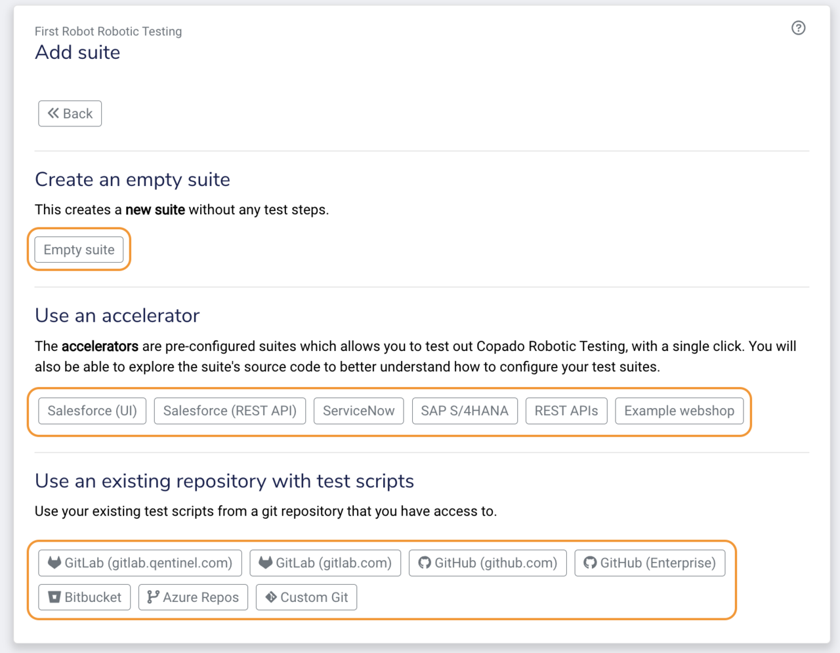

3. Once you select a method of creating a suite, your dashboard will look like this. For now, we have chosen **Example Webshop.**

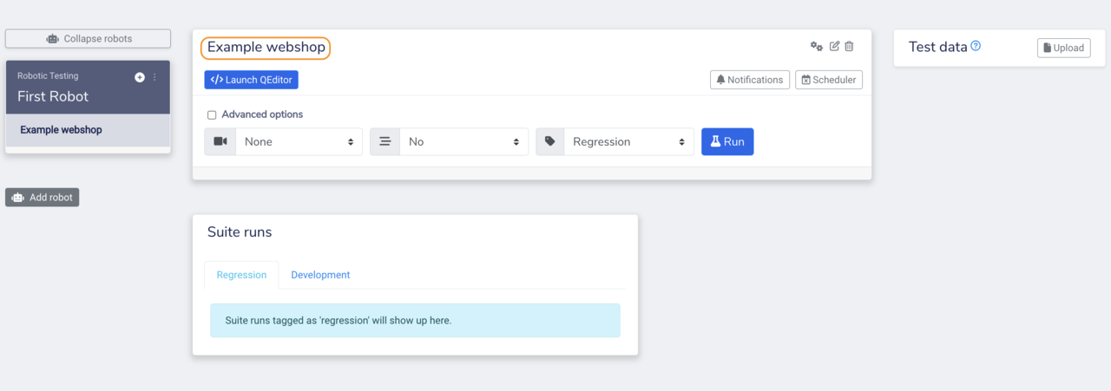

4. Now, launch the **QEditor** to create the test steps that you want to run.

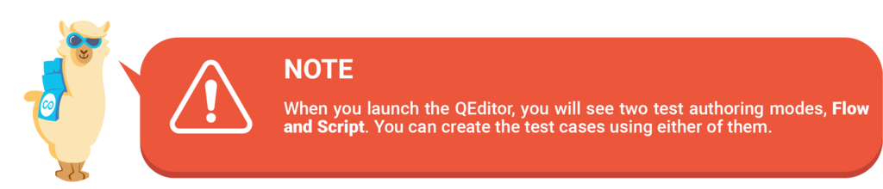

In CRT, you can author test cases via - **Flow & Script mode**. With Flow mode, you can add steps to your test by dragging the steps from the QWord Palette.

You can also check the smart prediction feature that will help you to choose from predictive test steps from the expected scenario. On the other hand, the script mode allows you to create test cases with the AI-guided feature.

**How to Link Your Suite With an Existing Repository?**

As you have noticed by now, Copado Robotic Testing, from creating an empty suite to using pre-set test scripts, gives you a plethora of suite-adding options that will lead you to perform testing in a convenient way.

In fact, you do not have to worry about creating and running fresh test cases if you already have a test script by your side and you want to host it from some other internal or external service. Copado Robotic Testing empowers you to create a favorable test environment by letting you connect your managed repository with the suite.

If your test cases are hosted at Public GitLab, Bitbucket or Public GitHub, you can generate a **Personal access token** and link your repository to your suite. **Follow**[**this documentation**](https://help.pace.qentinel.com/docs/current/appendix/gitlab.html) to know how to generate an access token.



However, if your repositories are hosted on some IP, local host or network, follow the given steps.

1. Navigate to the suite page and select the **Custom Git** option.
2. Fill in all the required details.
3. Click on **Save**.



**Variables and Execution Parameters**

Variables, in general, are one of the integral functionalities of the Robot Framework often used to replace or update test data values. With variables, you can define the placeholders in your test script and what values you want to apply to the placeholders during the test execution. Here you can define global variables for the project, robots, and suites. You can also view or modify your personal variables.

A personal-level variable is your access token which you will generate while authenticating against a GitHub, Bitbucket, or GitLab. On the other hand, a project-level variable could be a specific domain name, user credentials, etc. for the system under test, which you want to access in your entire project.

Suppose during a test run, you want a username to be replaced with a particular value, let's say, Jonathan. You can do so by setting variables as shown below.

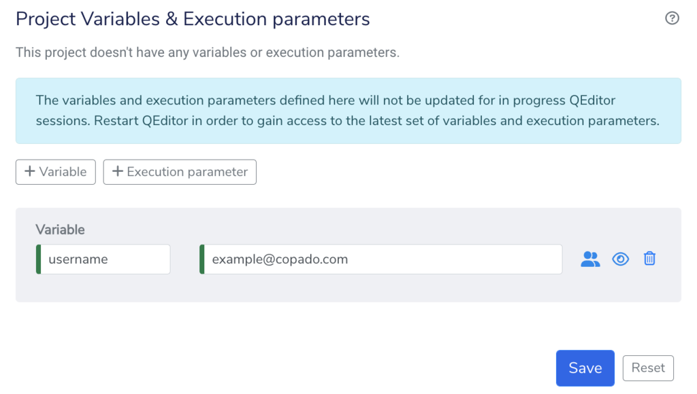

Now you must be wondering what the role of the execution parameter is in a test run scenario?

Well, execution parameters let you control how test cases will perform and what outputs will be generated. So for instance, if you need to pass some simple values with command line parameters such as including a certain test case with a tag name**“Local”** to the test methods at runtime, you can use this approach.

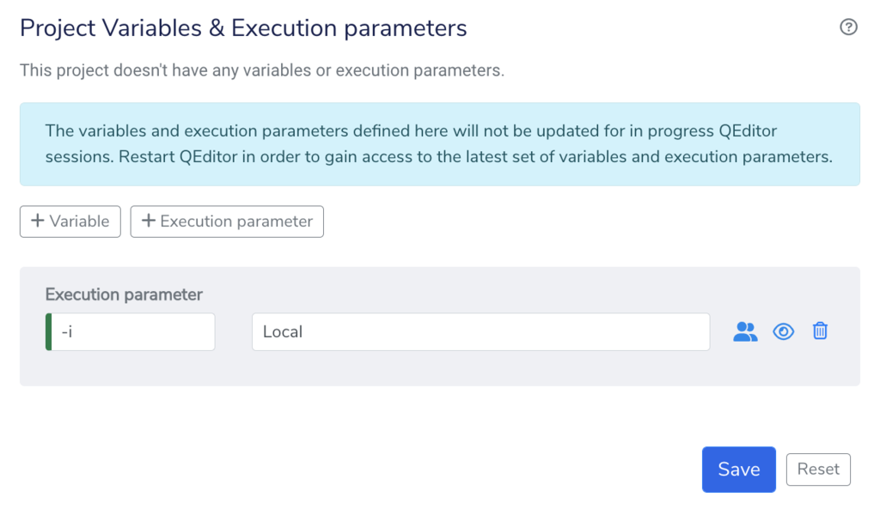



**Deleting a Suite**

When deleting the test suite, you need to follow the same order as you have for the project and robot. Follow the steps below.

1. Navigate to your **Suite** page.

2. Select the suite you want to **Delete**.

3. Click on the **trashcan** icon.

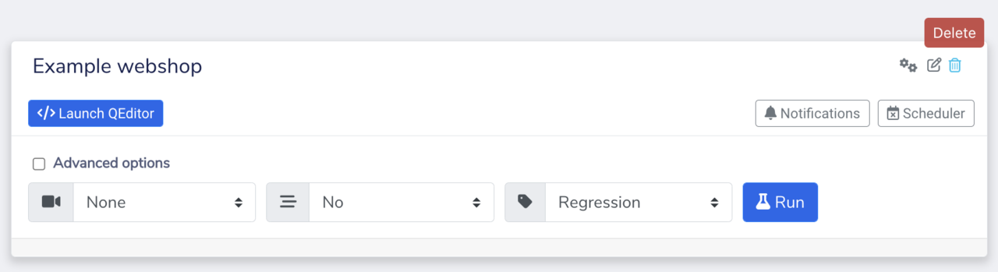

4. Enter Suite name and select **OK**.

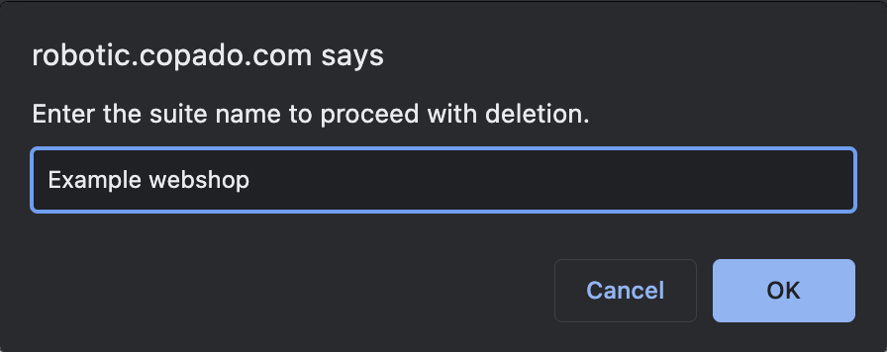

When you delete a suite, there is some data that will still remain stored in the Copado Robotic Testing container while some specific records will be deleted. Let’s have a look at what gets deleted and what outlasts.

**What will be deleted**

* Test Suite and its settings.
* All logs, videos, previous runs from Copado Robotic Testing UI.
* Suite data will not be available for any newly created dashboards.

**What will remain**

* Previously executed test statistics.
* Suite data for existing dashboards.

**Resources**

[*Suites Overview*](https://docs.copado.com/articles/#!copado-robotic-testing-publication/suites)

**Get Familiar with Suite Panel**

In the previous unit, you learned how to add a suite to your robot and initiate testing. Once you finish setting up your suite, you see plenty of components on your suite panel.

If you are wondering what each of these sections and subsections is used for, let’s tap right into it and inspect them closely.

For better understanding, we have divided the suite page into three sections -**Leftmost, Lower-middle and Lower-right.**

**Elements of leftmost section**

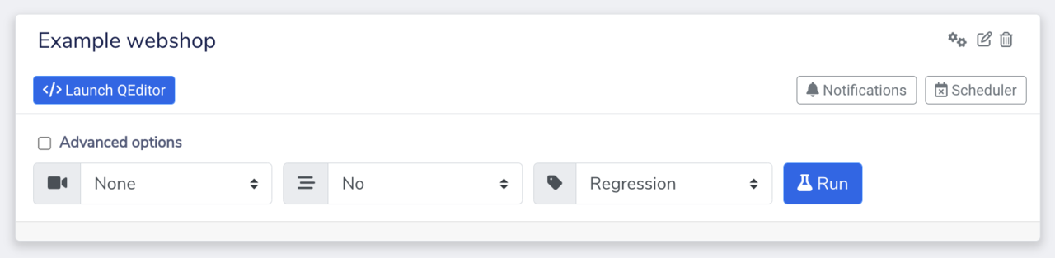

* **Suite name:**On the left-most corner of this dashboard is the name of the suite you are currently in. In this case, it is the Starter suite.
* **Suite segments:**In this section of the suite panel, you can see a variety of options which are Launch QEditor, Scheduler, Notifications, Run, Advanced options, Record Video, Stream Video, Suite run type and API options. Let’s understand the functionality of each of them carefully.
  + Launch QEditor: The space where you can see, edit and modify the structure of your test case.
  + Scheduler: This choice allows you to schedule test runs at predefined intervals.
  + Notifications: Notifications are set to receive status updates on suite run events.
  + Advanced options: Using advanced options, you can see the suite execution script assigned to the suite.
  + Record Video: This option enables Robot to record videos of executed tests.
  + Stream Video: This option enables Robot to live stream the test run.
  + Suite run type: You can decide the type of suite run between Regression and Development.

**Element of lower-middle section**

* **Suite runs:**In the lower middle space of the suite dashboard, you see the suite runs field. As the name suggests, suite runs enable you to understand the behavior of your test executed under that suite in real-time. It walks you through different strands of the test run such as detailed test generation report, run time etc. You can examine the test behavior for each suite type i.e. **Regression and Development**.

**Elements of lower right section**

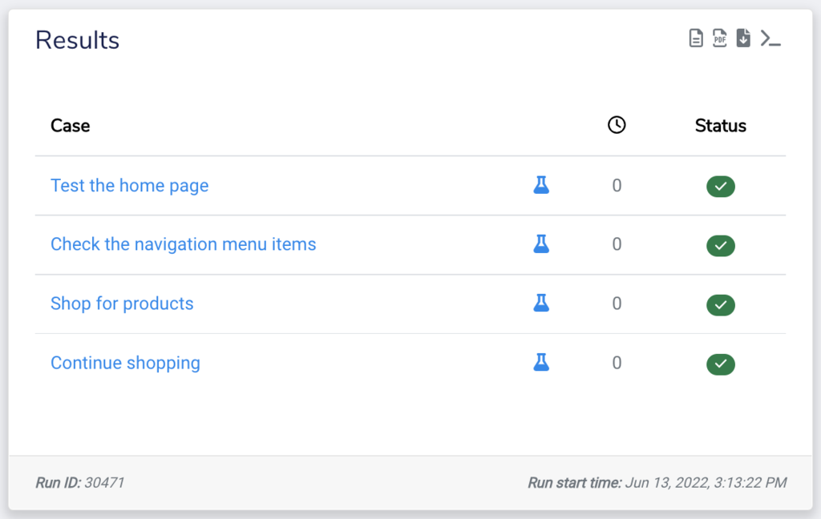

* **Suite result:**This section gathers and displays the quick summary of your test run that sums up the absolute status of test steps performed under a suite. In the detailed suite results, you can check detailed test execution results, download PDF reports of your test case results, and run artifacts. In case you opted for recording the videos, whether for all or just for the failed runs, it will be visible to you under the Video section. We will talk about the elements of the Suite result in detail in the upcoming unit.

**Copado Robotic Testing Basics Cheat Sheet**

This cheat sheet puts together all the major points discussed in this module and makes it easy for you to organize useful information for your Copado Robotic Testing certification.

[](https://copado.my.salesforce.com/sfc/p/#b0000000YN5R/a/5p0000019yS7/Z7Fn.8Gvc4gK1ys5_naVN9sSt6PwqpIVfwpklF3b7GY)

*Well done! You have almost reached the end of the module. We hope you had a great time learning about the****basic elements of Copado Robotic Testing****. After completing the next unit, go ahead and take the quiz to add a new shiny badge 🏅 to your achievements. Good luck!*

Done!

**Learning Objectives**

After the completion of this module, you will be able to:

* Explain the importance of cloud testing environments.
* Describe different ways to configure and run test cases.
* Know how to modify the test scripts depending on test scenarios.

﻿

[](https://success.copado.com/s/my-learning)

**Glossary**

The given list of words introduces you to certain technical terms used throughout this module. Have a look! 👇🏻

* **Cloud-based testing:**It is the process of evaluating the reliability of software or web applications on the internet over a distributed environment.

* **API:**API stands for Application Programming Interface which acts as a mediator in establishing a connection between two applications.

* **Robot Framework:** Robot Framework is a keyword-driven automation framework. It is generally used to test and automate software and business processes.

* **Keyword-driven testing:**Keyword-driven testing is a new testing concept that allows users to create test cases based on action words.

* **Scripting syntax:**Syntax is usually a description of something. Here the scripting syntax can be defined as an explanation of how the test scripts would be used while performing test automation.

*Find more definitions of any Copado term in the*[*Glossary of Terms article*](https://docs.copado.com/article/s13ocfrvae-glossary-of-terms)*.*



**Introduction to Cloud Testing Environment**

In this unit, we will learn about cloud testing infrastructure and understand how cloud-based testing infrastructure works. We will also have an in-depth analysis of creating and running test cases in Copado Robotic Testing over a distributed environment across teams.

Each component in Copado Robotic Testing has its own major part to play during the test execution. However, the most crucial thing here to understand is that all the elements are like interconnected branches forming a giant network of a testing environment.

For instance, you can’t create a suite independently, it should be connected to the Robot. Similarly, a Robot can’t work on its own, independently. It should be linked with a Project.

Cloud-based technologies and solutions give people the freedom to have an ecosystem that has immense accessibility and requires minimal adjustments. To manage work on the go, many businesses and users are shifting to cloud-based technologies.

But what exactly is the new testing approach that Copado Robotic Testing offers? How is it helping developers and testers to unburden themselves from the time-intensive coding and maximize testing reliability?

Let’s have a look.

**Importance of Cloud Testing Solution**

A cloud-based testing solution like Copado Robotic Testing can be a great option for businesses to perform end-to-end testing on the go.

Testing over the cloud empowers businesses to perform effective testing without dwelling on the installation, on-premise setup, and many other common problems you might come across in traditional testing methods.

Let’s understand the importance of cloud testing with the given use case.

The CreativiTee Company is an online store that sells personalized T-shirts. The development team has worked really hard to embed a **Wear and Decide** section on the website. This is basically a feature allowing shoppers to try on t-shirts virtually before making a purchase.

The company, before making the feature live for the customers, wants to quickly and accurately test if all the configuration of it is working properly. The CreativiTee Company took to Copado Robotic Testing, the next-generation test automation tool.

Copado Robotic Testing’s ready-to-be-deployed cloud infrastructure made it easy for the company to perform automated step-by-step testing without a hassle. Its intelligent robots executed test cases developed by the CreativiTee company to evaluate the **Wear and Decide** functionality.

Done!

**Major Components to Develop Test Case**

Copado Robotic Testing uses a predefined test case editor (QEditor) as well as a keyword-driven test script writing approach (QWords) to create maintainable test steps.

QEditor is a tool that you will be using to create and manage your test cases and QWord will help you draft your test steps in a simple and logical manner. That's the reason they are called the crux of the Copado Robotic Testing solution.

Let’s understand about QEditor and QWord in detail.

**What is QEditor?**

Let’s suppose you have configured your Copado Robotic Testing account. Your project is ready, your robot is set and your suite is active as well. Now what? What steps would you take to create and edit the test cases? How would you know the structure that needs to be followed while creating a test case should be like? This is what **QEditor**is for.

QEditor automatically gets configured during the suite creation process, however, you still need to add or create test cases manually as per the testing requirements.

In Copado Robotic Testing, QEditor enables you to add, delete or edit test cases. It also lets you create new files and folders. In fact, you can even save or commit changes and launch live testing sessions using QEditor, which we will be discussing later in this module.

**﻿What is QWord?**

As you know, Copado Robotic Testing does not work on the idea of using complex test scripts that are hard to understand for non-developer users. This is the reason our team of experts contemplated and chose to use natural language keywords which are generally known as **QWords.**

QWords are simply written keywords that enable you to write test cases with high readability, usability, maintainability, and robustness. For example, if you want to verify a text within a website, you can type **VerifyText** followed by the text you want to verify.

**Create and Execute Test Case**

Until now you have learned how each of the Copado Robotic Testing elements creates a bridge between setting up a test run environment and performing testing.

You understood the relation between Project, Robot, and Suite, and how QEditor and QWords play a vital role in maintaining and executing test cases.

Now is the perfect time to glance over a test run use case in Copado Robotic Testing to understand exactly how each of the previously discussed elements comes into action.

**Use Case**

George Baker is one of Copado’s customers who just finished setting up his Copado playground named **BakerSpace**. George wants to try out Copado’s recently introduced features and customizations.

While exploring different cloud-based test automation tools, he came to know about Copado Robotic Testing, a newly launched product from Copado, that allows people with non-testing backgrounds to run testing on the go.

The idea of an end-to-end AI-powered test automation tool that requires no coding skills, made George go curious so much so he now wants to try the Copado Robotic Testing.

It did not take George long to learn the basics of the tool and how tests are run on it. George, as a starter, wants to dive in and verify the status of his newly created playground in Copado.

﻿Let’s see how he does this.

**Steps executed by George**

1. Signed up and logged into the Copado Robotic Testing account.

2. Setup his dashboard with Project, Robot, and Suite named Baker’s Project, Playground, and Copado Testing, respectively. This is how it looks now.

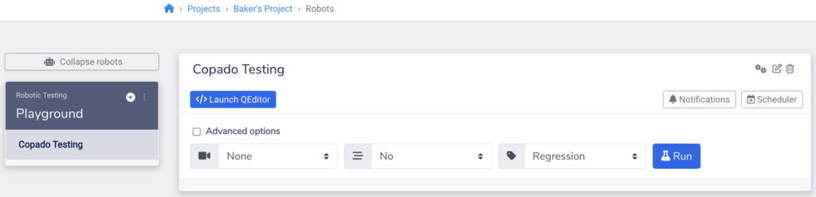

3. After that, he launched the **QEditor** and created test steps using QWords. Below are the test steps he is about to run to verify his playground details.

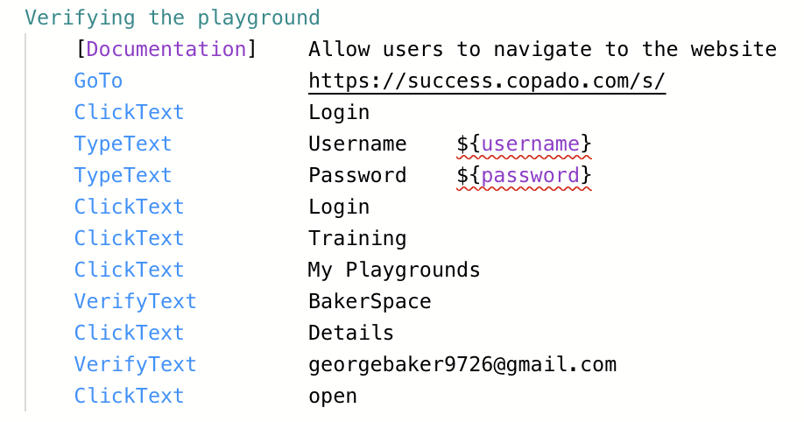

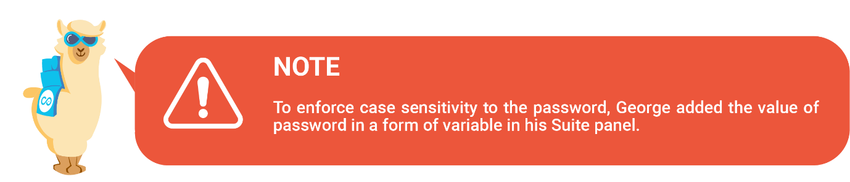

4. George is satisfied with the test steps he created therefore, he saves his changes.

5. Now, he will execute the process. To do that, he clicked on **Run Tests**under the Test Execution tab.

﻿

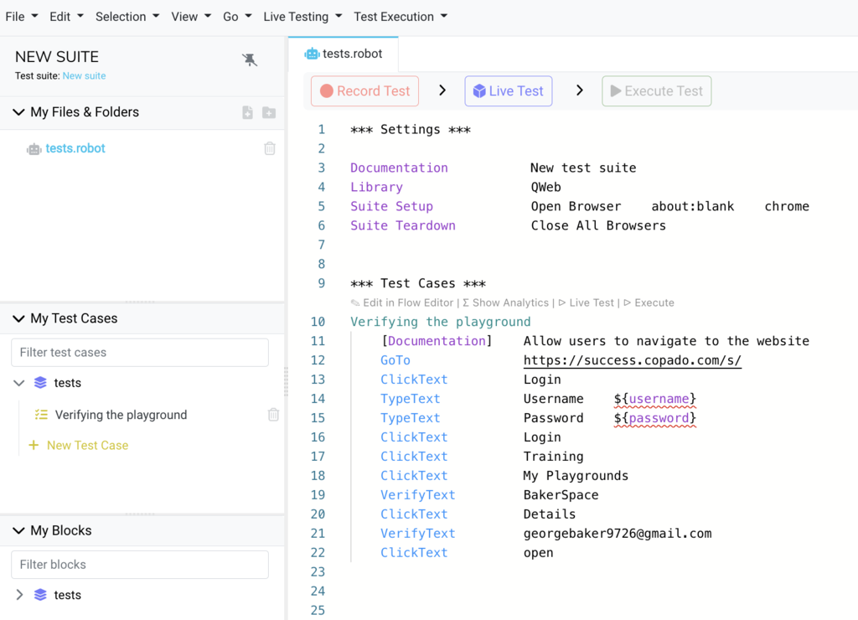

Copado Robotic Testing starts the test process in the backend. The best thing George liked about this tool is he can track the progress of each test step parallelly through the **Live Testing**feature.

Copado Robotic Testing has now completed the testing process and George can see the results of the steps he demanded to run.

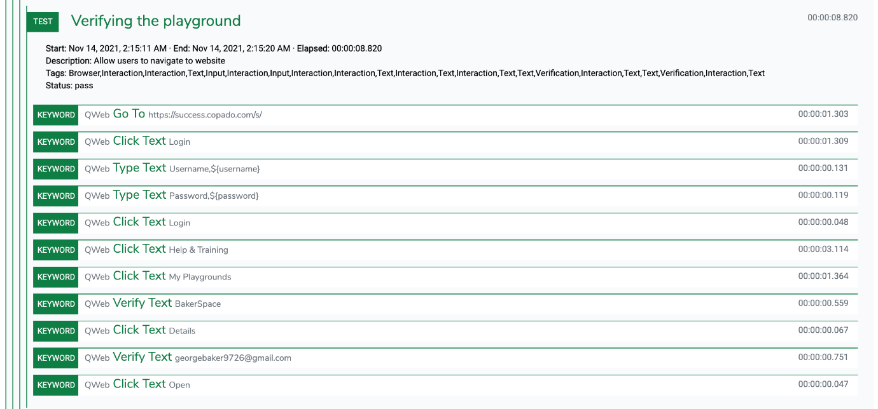

Amazing! George passed all the steps successfully 😀. The status in green for each step indicates that the test case is faultless and has passed the testing phase.

**Executing Test using Salesforce UI accelerator**

We just learned how a test case could be created and run from scratch in Copado Robotic Testing. Now we will look through a Salesforce case scenario where we will enter a lead and convert that lead into an opportunity using the Copado Robotic Testing tool.

**This is going to be an exciting learning experience! 🙂**

Tyler is a sales representative who works for FutureInvest, a health insurance firm. His company has recently launched a health insurance plan with an employee benefits package that allows enterprises to personalize the policy that best fits their organization.

Ever since the launch of the policy, Tyler has got many upfront prospects who have expressed interest in the term insurance plan.

Yesterday, he received a big potential lead from Tina Smith, who works for GrowMore as a finance operation manager. Tina is looking forward to rewarding its employees with FutureInvest’s personalized health plans.

Tyler now wants to create a lead record in Salesforce with Tina as her customer and then convert that lead into an opportunity.

Let’s see how he does this using Copado Robotic Testing’s Salesforce UI accelerator.

Salesforce UI accelerator is a predefined test suite that helps you start testing in the Salesforce cloud. However, you can adjust the test case as per your needs. This is what Tyler did.

**This is what Tyler’s test case looks like.**

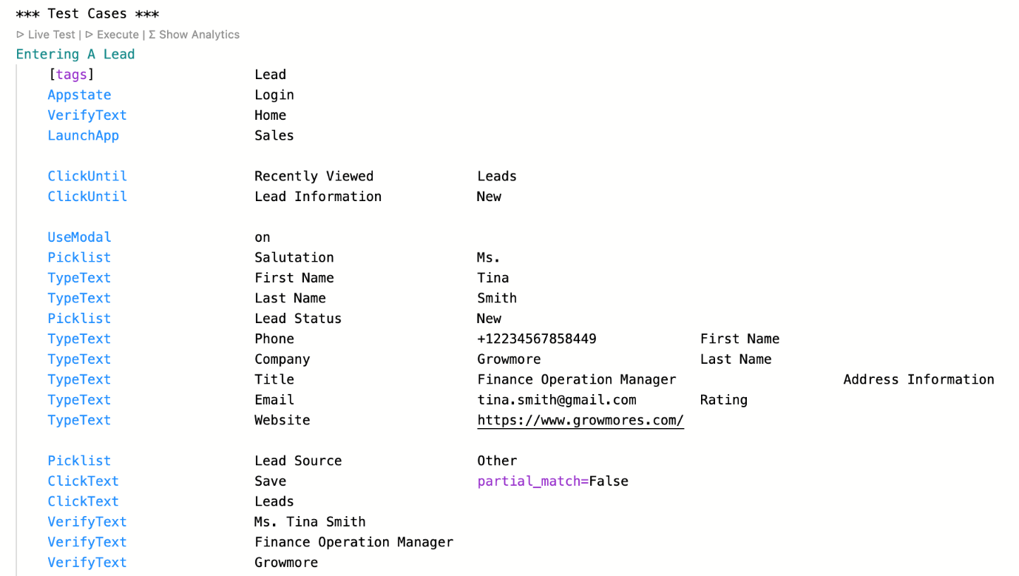

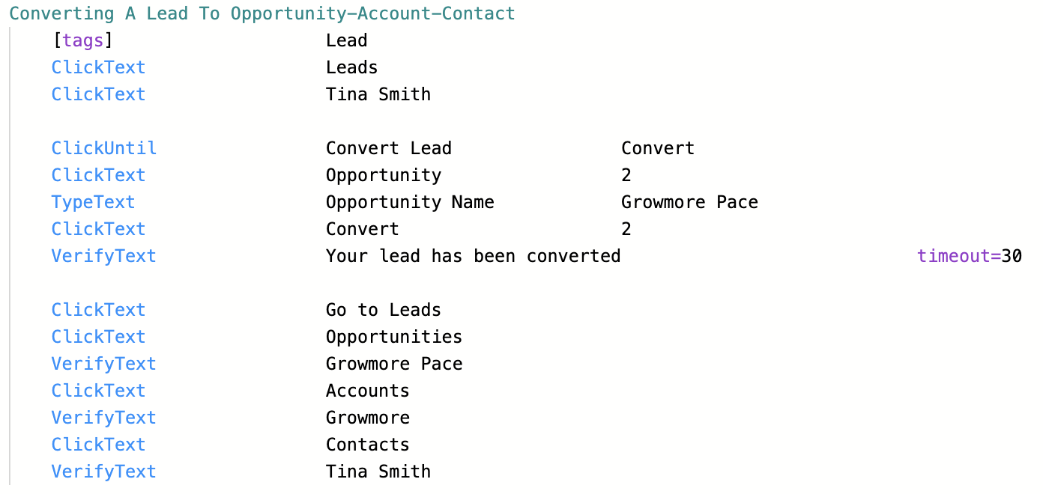



Tyler saved his changes and executed these two test cases in Copado Robotic Testing.

His test cases were executed successfully. Here are the detailed test execution results he checked for his test.

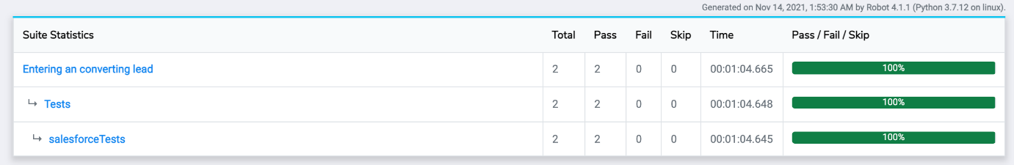

This Suite Statistics shows that Tyler ran two test cases in total, and both of them successfully passed.

**Data Driven Testing**

Copado Robotic Testing also allows you to run test cases with different data. That means you can use the same test suite to perform testing with different data. This is known as the Test data feature in Copado Robotic Testing. The test data feature is an excellent option if you are running localization testing with different languages or performing the same tests using different product IDs.

Let’s have a look at how to upload and run test data in Copado Robotic Testing.

1. Login to **Copado Robotic Testing Account** and Navigate to the **Suite** page.

2. Click on Upload under the **Test data** section.



3. Now upload your file containing the test data. The supported file types are CSV, TSV, Excel, and OpenDocument Spreadsheet.

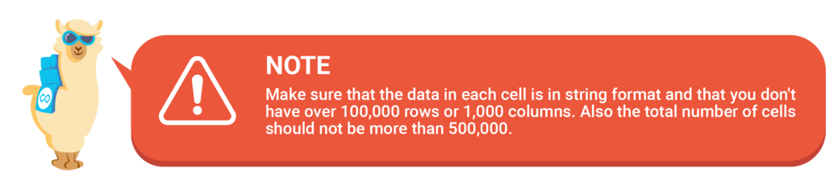

4. Select where your variables are on, row or column.

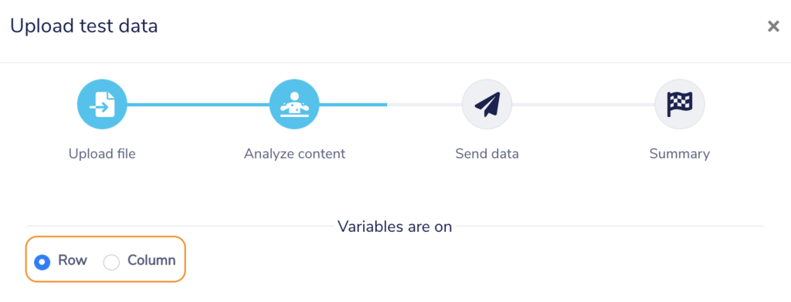

5. Select **Send to cloud** and click Send.

After this, the system will analyze your file format and provide the case template. You can choose from the following options:

* **Selected data for multiple tests:**This option makes a data row available as a global variable for all the tests in that suite.
* **All data for a single test:** This option allows you to iterate over a single test case with each data row.

6. Now select the file and data and click **Save**.

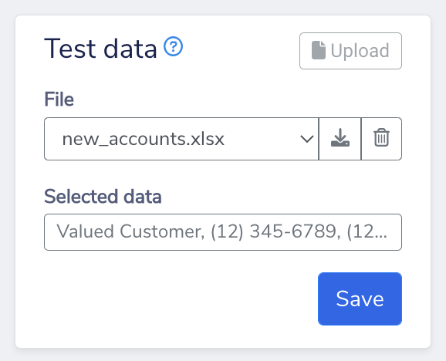

**Prepare and Run Tests**

After uploading the test data, you need to prepare your test cases accordingly. Ensure to use the variable names in Robot Framework format. For example, the username in your file will be written as **${username}** in your test script.

Also, you should add a keyword that enforces the test case into the **\*\*\* Settings \*\*\*** section. Once you have created your test case, you can run your test suite normally using Copado Robotic Testing.

Instead of running just one case with static data, Copado Robotic Testing dynamically creates its own test case for each dataset (row or column).

**Configure Test Runs via Different Methods**

The journey of creating a reliable and no-code test process in Copado Robotic Testing begins with creating and adding a test suite. Once you add the suite in a Robot, you have basically specified what you want to achieve with a product or component you are going to test.

After that, there comes a step where you have to determine the test method. In Copado Robotic Testing, you will have three options to execute testing steps.

* **Running Test Manually:** With this method, you can select the suite and click on the run button. Prior to the test run, you can select from regression or development testing and if you want your test process to be recorded or streamed as a video.
* **Scheduling Test:** Copado Robotic Testing provides you with an option to schedule test cases. So if you want a test case to be checked repeatedly, you can schedule runs at predefined intervals.
* **Using API key:**The API options enable you toperform testing through API keys. If you want to hook the test robot and suite into your continuous integration pipeline or other external sources, you can trigger a test run through the API key.

**How to Create a Test Case Using API Key?**

One of the methods to configure and execute testing in Copado Robotic Testing is through API. First, you need to generate an API key, and then you will be using that API key in your scripts to trigger tests. Follow the given steps to generate an API key.

1. Navigate to the suite you want to create an API key for.

2. Click on the **API options** icon as shown in the image below.

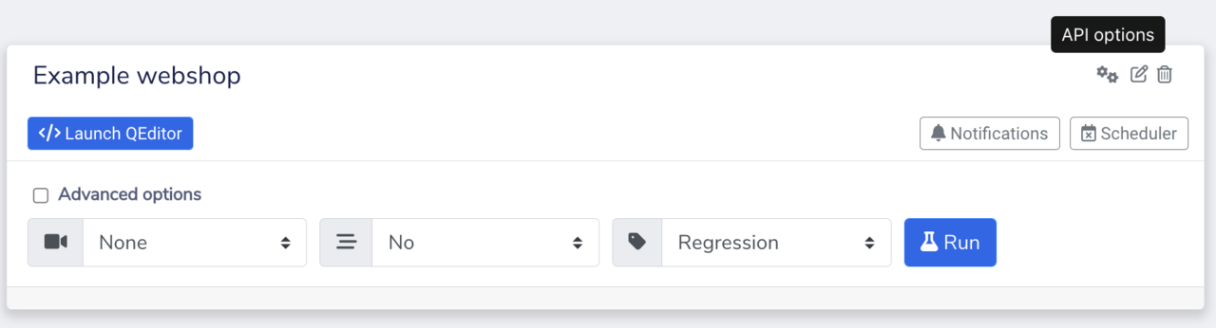

3. A popup window will appear asking you to generate an API key. Click on **Generate**.

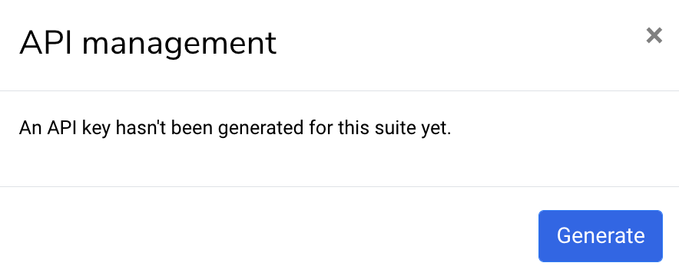

4. You will then see the strings of codes with the combination of numbers and letters. That is your API key.

5. Now go to the tool that you will be using to send API calls. For instance, Copado.

6. To start the test process, replace the URL (with the given one) and API key (with generated one) in your script.

**Bash Example Script**

Here we have provided a bash example script so that you can integrate the setup easily. You will need to replace your test script along with providing valid arguments with the given information:

* **PACE_API_URL:**<https://eu-robotic.copado.com/pace/v4/builds> or <https://robotic.copado.com/pace/v4/builds> **(for US instance)**
* **PACE_API_KEY:** The API key you just generated for your suite

#!/bin/bash

PACE_API_URL=<https://pace.qentinel.com/pace/v4/builds>

PACE_API_KEY=[YOUR_API_KEY_HERE]

# Start the build

BUILD=$(curl -sS -d '{"key": "'${PACE_API_KEY}'", "inputParameters": [{"key": "BROWSER", "value": "firefox"}]}' -H "Content-Type: application/json" -X POST ${PACE_API_URL})

echo "${BUILD}"

BUILD_ID=$(echo "${BUILD}" | grep -Po '"id":\K[0-9]+')

if [ -z "${BUILD_ID}" ]; then

exit 1

fi

echo -n "Executing tests "

STATUS='"executing"'

# Poll every 10 seconds until the build is finished

while [ "${STATUS}" == '"executing"' ]; do

sleep 10

RESULTS=$(curl -sS ${PACE_API_URL}/${BUILD_ID}?key=${PACE_API_KEY})

STATUS=$(echo "${RESULTS}" | grep -Po '"status": *\K"[^"]*"' | head -1)

echo -n "."

done

echo " done!"

FAILURES=$(echo ${RESULTS} | grep -Po '"failures":\K[0-9]+')

LOG_REPORT_URL=$(echo "${RESULTS}" | grep -Po '"logReportUrl": *\K"[^"]*"')

echo "Report URL: ${LOG_REPORT_URL}"

**Difference Between Regression and Development Runs**

While prospecting the suite dashboard, you might have mulled over regression and development test types. So let’s talk a bit about them also. If you are going to run your test cases, you should know the difference for sure.

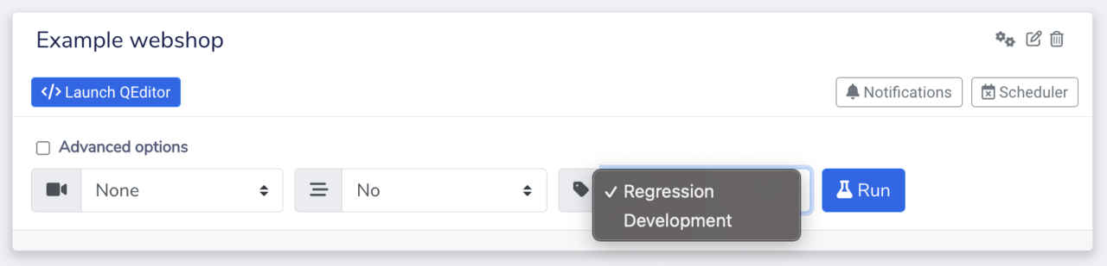

As mentioned previously, you can choose from two testing-type options. Regression run comes as default, but if you want, you can change it to development.

* **Regression Run Type:**Regression runs are standard test runs that you execute, results of which will be available to show in the metrics and dashboards. Development runs, on the other hand, are meant to be used when you are testing newly introduced changes to your existing or new test cases.

* **Development Run Type:** Development type test run is mainly used to determine whether your test steps are working correctly. Development runs are not included in metric calculations and neither do they show up in your dashboard.

So let’s suppose if you want to run your test case and do not want your metrics to get messed up, development run will be your test type.

**Suite Result Summary**

Suite results summary enables you to see important test run information with just one glimpse which could be identified in two cards - **Suite runs and Results**.

In previous units, we learned how these two sections helped us get deep insight into the performance of our test case while discussing the different components of the suite dashboard.

Let’s throw some light on each of the sections and analyze the information they disclose after completing the test execution.

**Suite runs**

1. Run ID

2. Run start time (time when the test started)

3. Results (number of executed test cases, passed as green and failed as red)

4. Duration (time taken for execution in seconds)

5. Recording (availability of video recording)

6. Actions​​​​​

* Detailed test execution results
* Test generation result
* Execution parameters used

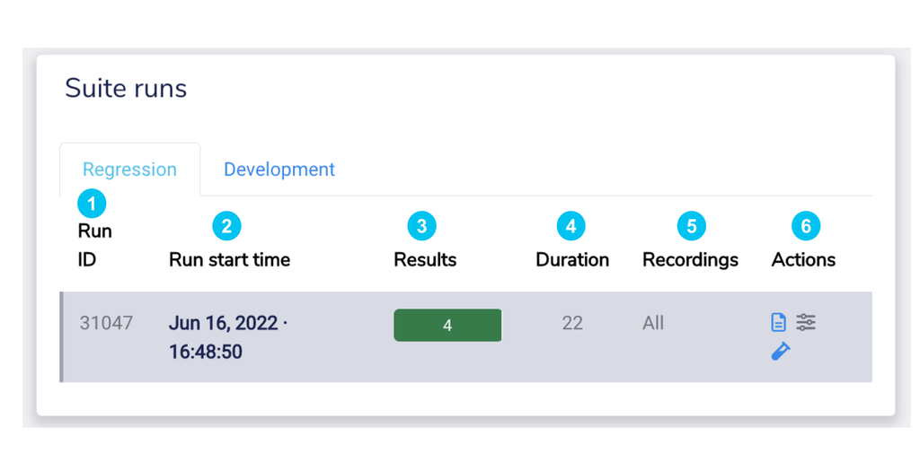

**Suite Results**

1. Test case name

2. Duration (time taken for test execution)

3. Status (test execution status)

4. Actions

* Launch QEditor and start live testings session
* Show video

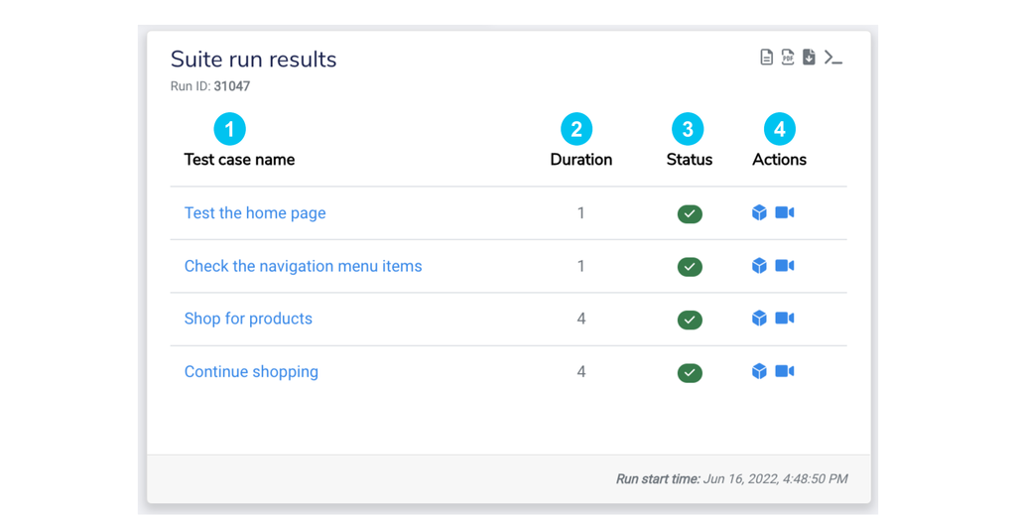

**Analysing Failed Test Steps**

Analyzing the test automation result effectively requires rigorous effort, especially when you see your test steps failing at a certain level. Test cases will fail sometimes and fixing the problem is the utmost responsibility of the development team, but how easy and effortless the fixing process is going to depend solely upon how accurately you managed to understand the detailed test report.

Copado Robotic Testing, by putting forth a simple explanation of the test statistics, makes the test result analysis process as efficient as possible. As you know, when it comes to verifying the test result, providing a structured and streamlined approach plays a vital role in the success and this is exactly the strategy of Copado Robotic Testing.

In Copado Robotic Testing, the test suite run produces a detailed report which contains statistics and an execution log that is feasible to examine. On the other hand, the results space gives you insight into the detailed report page, where each execution log contains keyword-level information. This enables you to check each step of test execution to further understand at which step your test case failed and why.

To understand the statistics of failed test steps more sharply, let’s take an example of the test case Geroge executed in the former unit but this time we will add one more test step to fail intently.

**The new test step looks like this -**

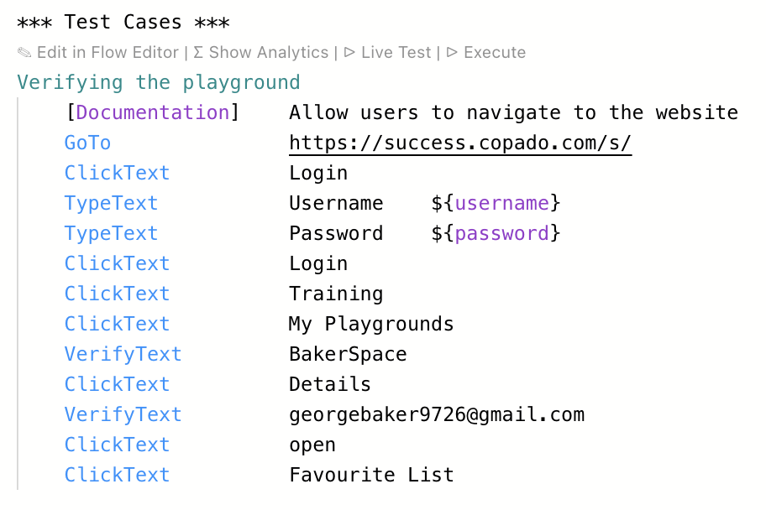

The test case failed at the last step “**ClickText Favourite list”**. The reason that has been asserted here is that the find element couldn’t locate the Favourite list to verify.

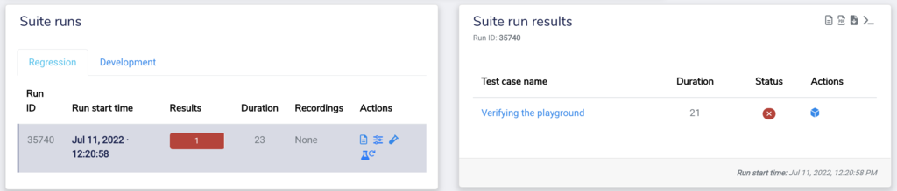

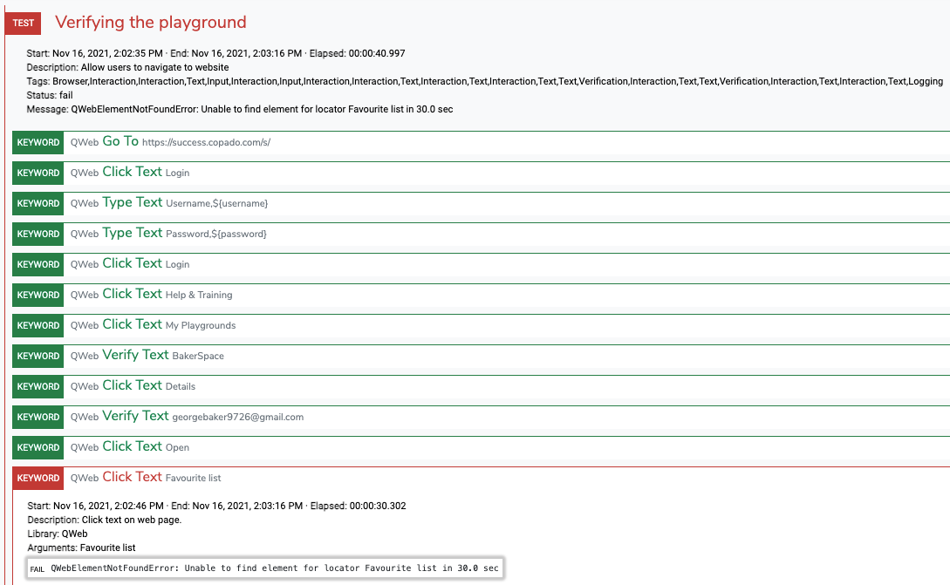



**Dashboard and Metrics**

In Copado Robotic Testing, a standard dashboard is included in a project by default. A dashboard, located on the Robots page within a project, shows data that robots produce by running test suites.

﻿It helps to visualize what is the status of the project by showing relevant metrics. By hovering the mouse over metrics you can get more detailed information. A standard dashboard includes the following metrics:

* Latest run results
* Daily pass/fail trend
* Daily usage
* Cumulative test cases

﻿

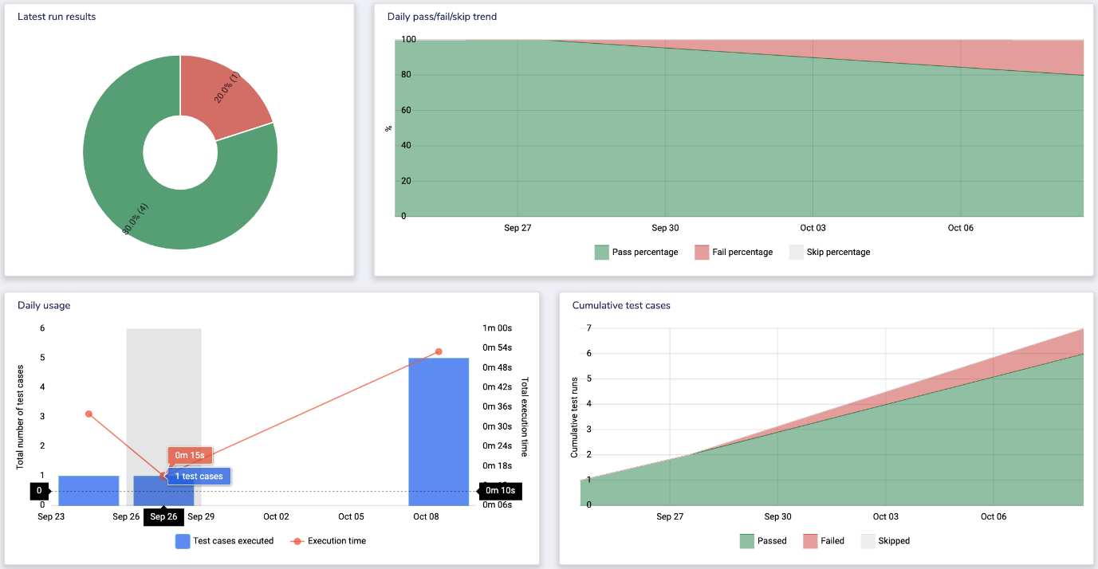

**Expanding Knowledge to QEditor**

QEditor, as described before, is a new-age advanced panel in Copado Robotic Testing that engineers your test run without requiring you to write a bunch of complicated test scripts. It can also be understood as an intelligent dashboard that records your simply written test steps and enables you to navigate through different preferable menus.

With QEditor, you are empowered to check the progress of each run on the go through the Live Testing feature. To launch the QEditor control panel, navigate to your suite and click on **Launch Editor**. It should also be kept in mind that you can customize the QEditor panel as per your preferences.

This is what the panel will look like during the launch in the first instance.

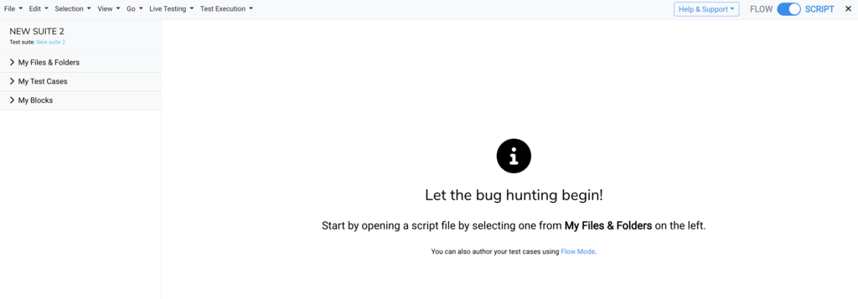

Irrespective of whether or not you own a project, you will be able to open QEditor for a git suite if you have been granted rights to do so. The editor might or might not need extra configuration to open up.

Now you are into the QEditor dashboard, on the left-hand side, you can spot the following -

* **My Files & Folders:**This space is reserved for keeping files and folders as a part of the suite.
* **My Test Cases:** This is the space where you manage all your test cases.
* **My Blocks:**This is the space where you can manage all your custom keywords.

**QEditor Menus & Scripting Syntax**

It is true that QEditor lets you get started with the test steps and gives you a variety of options to modify test cases at your convenience. However, its workability is not limited to certain defined conditions.

There are plenty of functionalities you can explore in QEditor and get a holistic view of the panel that eventually leads you to unleash greater testing potential. Here, we will be map-exploring through individual components of the QEditor control panel.

* **Editor area:**When you first launch the QEditor, you will be notified by a welcome message. You can then switch from two authoring modes to create test cases.
* **Menu bar:**The next component you will come upon in your QEditor panel will be the menu bar. Each individual tab has its own tasks to perform.
* **Live Test:**This is the tab from where you can launch the **Live Testing** terminal and track the debugging session from start to finish.
* **Run test:**In the editor area, there’s a link to start a run for that particular test case. However, you can also navigate to the Test Execution tab and run the test cases in Development mode.

**Copado Robotic Testing Scripting Syntax**

This shows the correct structure and order of your test case.

|  |  |  |
| --- | --- | --- |
| **Fields** | **Definition** | **Example** |
| Test Case Name | It describes your test steps in a compact manner. Your test case should be clear and descriptive. | **Verify Text on Website** |
| Documentation | It is used to explain what your test case is intended to achieve as an end result. | **User to visit the website and verify the text for a particular product** |
| Tags | This syntax is used for classifying test cases and also to provide metadata to reports and logs . | **Shopping Cart** |
| Test Script | This is where you are defining the parameters and steps for QEditor to execute as a part of your test process. | **ClickText               Products** |

QEditor is also available as a Visual Studio Code extension. It’s a language server for robot frameworks in general, so it can be used to implement any robot framework scripts using any libraries.

In addition to normal features like syntax highlighting or the ability to detect errors in scripts, the extension makes it possible to develop test scripts locally, but then also run them in Copado Robotic Testing.

Done!

**Deep Dive to QWords with Use Case**

QWords to Copado Robotic Testing are what fuel to a car is - **the Most Important Component**. QWords can be defined as unambiguous self-explanatory keywords built-in to Copado Robotic Testing to perform test steps. You generally write and edit the QWords in QEditor’s editor area.

QWords are designed in a way so that you can create test cases using common actions such as TypeText, VerifyText, etc. This ultimately leads you to create test cases without being bothered by the complex scripts. Moreover, QWords enable you to write test cases with high readability, usability, maintainability, and robustness. QWords are implemented in three main libraries:

* QWeb (for web automation)
* QMobile (for mobile automation)
* QVision (Computer vision library, for desktop automation and more)

In Copado Robotic Testing, we have defined the role of each keyword and how it will function for the test cases. However, the best way to get familiar with the uniform nature of QWords is by using them in an actual test case. Let’s look over a use case to understand the use of QWords in the real-time scenario. In this exercise, we will take an example of a web page and test different components.

**Test case run exercise:**

1. Open this URL: [**https://qentinelqi.github.io/shop/**](https://qentinelqi.github.io/shop/)

2. Verify the text **The animal friendly clothing company** on the homepage.

3. Navigate to the product page of **Scar the Lion**.

4. Validate that the Add**to cart** button is visible.

5. Ensure that you are now redirected to the **Cart summary** page.

6. Remove item from the cart.

7. Verify that the cart is now empty.

8. Click on **Continue shopping**.

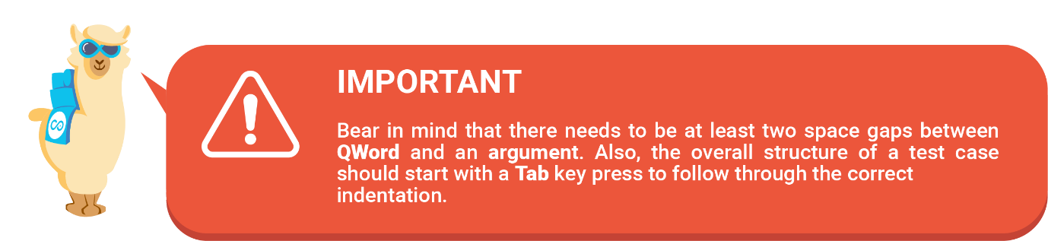

**Solution:**

1. **Navigate to a URL -**The first test step you will be triggering with QWords is **GoTo** which would be supported by two arguments i.e - which URL to open and which browser to be used. The final step would look like this -

GoTo       <https://qentinelqi.github.io/shop>



2. **Validate the text -**When it comes to validating a text, component, or item, you generally do it via verification QWord in Copado Robotic Testing. The most common examples are **VerifyText, VerifyElement**and**VerifyItem.** In this exercise, we need to verify a text so the step would be -

VerifyText    The animal friendly clothing company



3. **Interact with elements -**Now comes the part where you need to interact with one of the elements of the web page. To do that, you should be using interaction QWords such as **ClickText, ClickItems**and**ClickElement**. Going by the exercise, you need to click on a textual link so the step should be -

ClickText     Scar the Lion



4. **Navigating and verifying text -** In this step, you will execute two steps at once as you have already learned about verification and interaction QWords. After navigating to Scar the Lion page, you need to validate Add to Cart button and make sure we are on the right page. Now your test script in QEditor would look like this -

ClickText      Add to cart

VerifyText     Cart summary

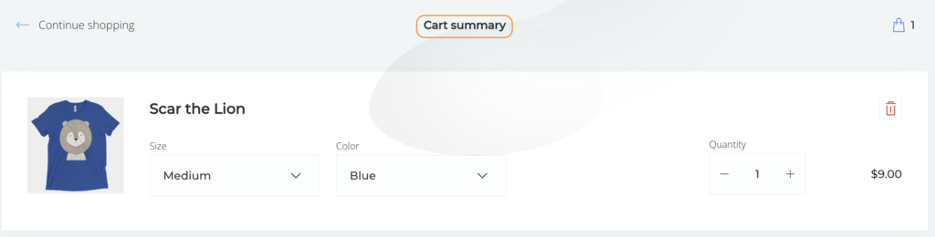

5. **Set product quantity to zero-**Now we need to decrease the quantity of the product from 1 to 0 so that the item will be removed from the cart as well. But as you can see the element you are going to write the test step for does not have any text. In that case, you need to check the element’s attributes and values. To do that, right-click on the web page and select *Inspect* on your browser. Then check the element’s attributes and values. For this exercise, the value that is given for the (-) element is **Decrement quantity**. So let’s use the same argument.

ClickItem     Decrement quantity



6. **Verify and click on text -**The last step of the exercise here is to substantiate if your cart is empty and then continue with the shopping. Here are the steps that would be triggered.

VerifyText     Your cart is empty

ClickText     Continue shopping





**Final test case should look like this**

***Test Cases***

Remove item from the cart

[Documentation]   Select product and verify details on the page

GoTo             <https://qentinelqi.github.io/shop>

VerifyText         The animal friendly clothing company

ClickText         Scar the Lion

ClickText         Add to cart

VerifyText         Cart summary

ClickItem         Decrement quantity

VerifyText         Your cart is empty

ClickText         Continue shopping

Well done! 👍🏻 You have successfully managed to learn the role QWeb QWords play in creating and running test cases and during the exercise, you also got along well with carrying out an interesting test case.

**Common QWeb QWords**

As you know that Copado Robotic Testing QWords replicate common user actions that are carried out while running the test case, here are some common QWeb QWords that are used in almost all the test cases.

* **ClickText:**Click text on the webpage.
* **ClickItem:** Click item (usually icon or picture) on webpage.
* **ClickElement:** Click element specified by xpath.
* **TypeText:**Type given text to a text field.
* **VerifyText:** Verify page contains given text.
* **VerifyElement:** Verify that element can be found on the page and it is visible.
* **OpenBrowser:**Open new browser to given URL.
* **GoTo:** Switch current page to given URL.
* **CloseBrowser:**Close current browser.

[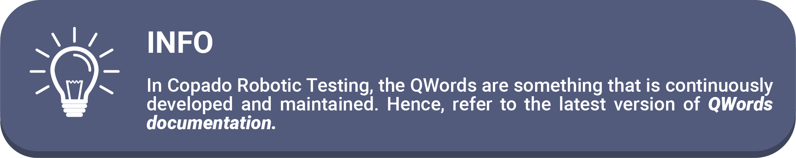](https://help.pace.qentinel.com/qwords-reference/current/index_qwords.html)

**QWords Best Practices**

* Use clear and descriptive test case names, e.g. Open Help Page.
* Use [Documentation] to explain the purpose of the test case.
* Make the test case reader-friendly.
* Leave an empty line after 10 lines, use Log to describe the next section.
* Use [Tags] for running selected test case groups, e.g. ok or not ok when designing new test cases.
* Appstate must be the first step in a test case; navigation to pre-condition.
* Do not use Sleep keywords.
* Try to avoid extended use of project-specific keywords, no more than 100 keywords total per project
* Use teardowns to close the test session properly.

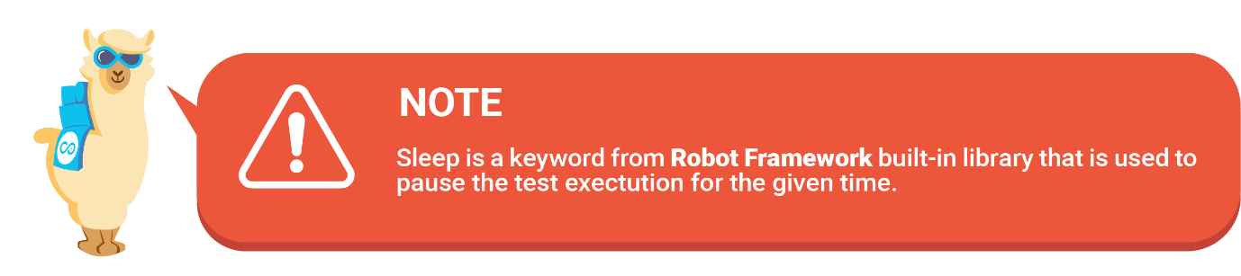

**Copado Robotic Testing Intermediate Cheat Sheet**

We have taken down key points of this module and arranged them in a cheat sheet. Refer to this concise set of notes for quick reference.

[](https://copado.my.salesforce.com/sfc/p/#b0000000YN5R/a/5p0000019yUr/7nsSP3z6VH9XgqbQ2m8muuaiqJruhaEgvBN9tgy_NJ8)

*Well done! You have now reached the end of this module. We hope you had a great time learning about the****improved functionalities of Copado Robotic Testing****. After finishing the next unit, test your knowledge with our quiz and add a new shiny badge 🏅 to your achievements upon completion. Good luck!*

**Learning Objective**

After the completion of this module, you will be able to:

* Learn about Copado Robotic on-premise testing.
* Discover how to create custom keywords.
* Get a broader understanding of the automated test designs.

[](https://success.copado.com/s/my-learning)

**Glossary**

Let’s get familiar with the definitions of some key terms that you will come across during the learning of the module. 🤓

* **Test project:**Simply put, a test project is a container where all your files and folders, relevant for managing test cases, are stored.

* **On-premise testing:** On-premise testing is commonly known as running tests in your local systems.

* **Authorization string:** It is a unique security token that is generated to verify the authority of accessing QConnect and establishing a connection between QConnect and Copado Robotic Testing.

* **SDKs:**Stands for Software Development Kit, SDK is a collection of tools used to develop software or applications.

* **Test designs:** Test design can be described as an activity of specifying conditions in test cases adjustable to a testing environment.

*Find more definitions of any Copado term in the*[*Glossary of Terms*](https://docs.copado.com/article/s13ocfrvae-glossary-of-terms)*article.*



**Copado Robotic Testing Libraries**

In the previous module, you learned about the maintainable cloud-based test cases that can be created using QWords in Copado Robotic Testing.

Copado Robotic Testing platform is built upon open source technologies like Robot Framework, selenium, appium, etc., it is necessary to get a basic understanding of the test scripts and syntax that Copado Robotic Testing uses across the platform.

Managing test cases and executing steps using QWords has become easier than one could have ever expected. Copado Robotic Testing’s test scripts are prepared and managed by QWords, which is again implemented for different platforms such as **web, mobile, and desktop.**

From solving common problems in test automation such as latency to unexpected alerts, Copado Robotic Testing’s libraries are making it easier for everyone to have the best ever test automation experience.

QWords mostly relies on UI texts and simulates what a human would possibly do. For instance, you can click buttons/ links, verify a text on the screen, etc. While Copado Robotic Testing also holds up to more complex locators like xpaths, CSS selectors, or native objects IDs, the use of UI texts is strongly suggested as this reduces the maintenance effort needed.

As mentioned earlier, QWords can be implemented in three main libraries which are - **QWeb, QMobile and QVision**. To use any of Copado Robotic Testing’s libraries, you need to import it into your test script or resource file. For example:

**\*\*\*Settings\*\*\***

Library    QWeb

# or

Library    QMobile

# or

Library    QVision



When multiple libraries implementing keywords with the exact same name are used, you need to either set the search order or call QWords with a fully qualified name. Let’s see how you can do it.

**Set the search order**

Set Library   Search Order   QMobile

**Call QWords with a fully qualified name**

QMobile.ClickText      Home

QVision.VerifyItem     File

QWords focus mostly on testing major platforms on the UI level. Therefore, if you feel that your project requires an advanced framework, you can, in a similar way, import other robot frameworks’ built-in and third-party libraries. You can also create your own custom library with the help of custom keywords which we will know how to create in the next unit.

**Common Parameters for QWords**

QWord follows a simplistic approach to creating test scripts. Users with minimal or no knowledge of coding and scripts can easily create comprehensive test cases. But what if you need to write your test cases in a more abstract way with specific variations?

For instance, you want to verify an element within a browser after a specific time. For tasks like this, Copado Robotic Testing bestows you with commonly-used parameters that are freely configurable and can easily be assigned to the different test types in a variety of ways. Let’s go through each of them one by one.

**Timeout**

Timeout is one of the most commonly used parameters while creating test cases. A timeout parameter is set to 10 seconds by default but can likely be changed as per the requirements of the test case. QWord tries to complete its task within the specified time limit and continues to the next QWord as soon as the task is completed. If QWord is not able to complete its task within the time limit it fails and test case execution ends there. See the example below.

*VerifyText    Products    timeout=20*

**Locator**

Some of the QWords like TypeText require a locator. For instance, suppose you are verifying a few elements of a website and there comes a step where you need to locate a specific item via the search section. In that case, you can put the locator parameter into use. TypeText QWord helps you discover where to type given text. Usually, the locator supports text content but can be sometimes customized through XPath if there is no text available. See the example below where search is acting as a locator.

*TypeText    Search    Slim fit t-shirt*

**Anchor**

When you perform a test run, there are times when the page contains duplicate texts and you need to differentiate between the two. In the majority of test automation scenarios, it becomes very difficult for the developers to create a syntax that enables the tool to choose one over another but Copado Robotic Testing makes the process a cakewalk through anchor parameters.

While examining a website, application, or any business process through Copado Robotic Testing, whenever you come across a situation where there are duplicated elements, you need to specify an anchor, which is a unique text close to the correct one. Also, the index number is supported as an Anchor. See the example below where a website contains the text Help multiple times, but we want to click the one closest to the text Sell.

*ClickText    Help    Sell*

**Get familiar with Test File Structure**

Before you initiate your test case run, you will need to structure your test project so that it will be easier for you to keep it manageable. That means you can easily find the folders and files later on when you need them. It is a good practice to always use the same test project structure for every suite you have configured.

On the QEditor page, you can create folders with files, libraries, resources, etc. The recommended directory structure for any Copado Robotic Testing test automation project should be like the given one.

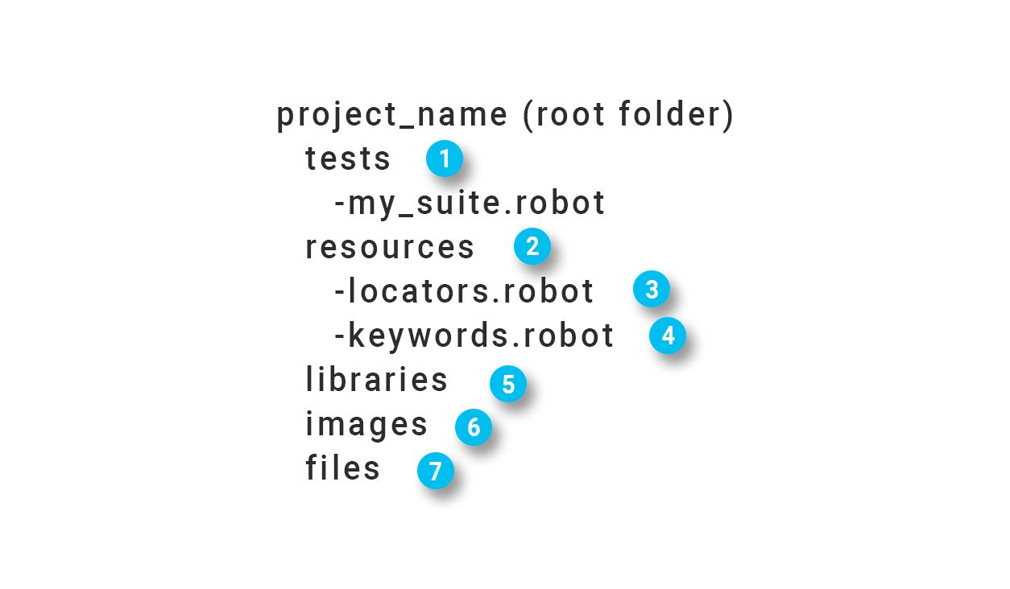

1. Test scripts/suites should be stored under the tests folder.

2. Additional resources should be stored under the resources folder.

3. locators.robot file should store variables for element locators (i.e xpaths etc.)

4. keywords.robot should store any additional custom keywords.

5. Any custom Python robot libraries should be stored under the libraries folder.

6. Reference images used in image comparison should be stored in the images folder.

7. Any additional files, for example, CSV files that contain test data, should be stored in the files folder.

**Breaking Down Test File Structure using Salesforce Starter Suite Example**

When it comes to creating a test project structure, there should be two folders that are mandated to be there - **Test folders and Resource folders.** For the purpose of having a broader understanding, we will look through a Salesforce starter suite example.

**Sections that should be in your tests folder**

* **salesforceTests.robot**

*** Settings *** and *** Test Cases ***

For the Settings part, we have defined the resources, suite setup and suite teardown we will be using for the suite while in the Test Case section, you can see the test case name along with the scores of test steps.

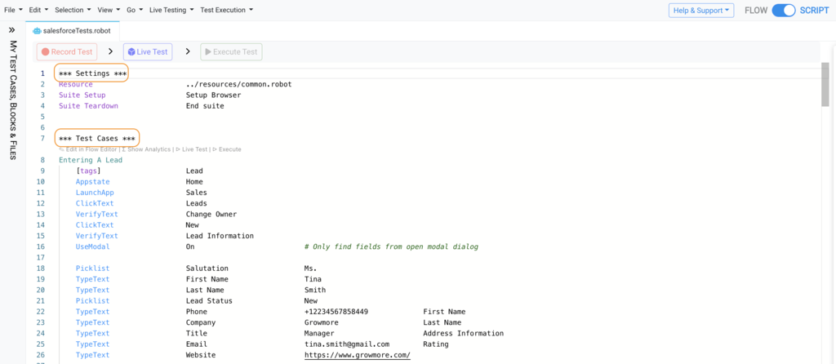

**Sections that should be used in your resources folder**

* **common.robot**

***Settings***, ***Variables*** and ***Keywords***

In this section, the setting level holds on to the details of the library that has been imported for this suite specifically. The Variables are defined for browsers and the list of supported keywords that will be used to configure the test structure.

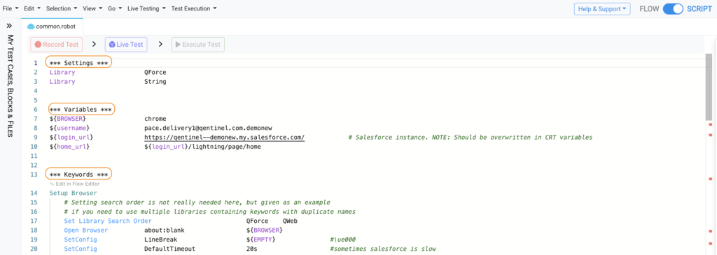

**Create Custom Keywords with QWords**

There would be many test case scenarios where you need to put combinations of keywords different from what Copado Robotic Testing provides. In that case, you need to create custom keywords. This can be done by grouping individual QWords that will form a new **Actionword**. You can make your QWords operate differently via Actionwords.

Custom keywords are normally used in situations where you notice that you need to write the same set of QWords to many test cases. You can either create two separate folders for tests and resources or can create one file with given sections.

* Settings
* Variables
* Keywords

For a fair understanding of custom keywords, let’s work through a use case.

Ramya is a senior software developer who wants to create a custom keyword named **copado login** that defines conditions for her login action in the Copado success community. She has created a custom keyword using QWords and has defined certain parameters. For security purpose, Ramya has added a Variable in the suite that carries her account password. Let’s have a look at the anatomy of the Keyword subsequent to Settings and Variables.

Ramya defined the test level configuration along with variables. 

**\*\*\*Settings\*\*\***

Documentation           Test suite for salesforce login

Library                        QWeb

Suite Setup                Open Browser             about:blank              chrome

Suite Teardown          Close All Browsers

**\*\*\*Variables\*\*\***

${BROWSER}                  chrome

${username}                    [ramyakrishnan96@gmail.com](mailto:ramyakrishnan96@gmail.com)

${login_url}                      <https://success.copado.com/s/>

**\*\*\* Keywords \*\*\***

copado login

    [Documentation]            Make users login to the copado success community

    GoTo                              ${login_url}

    ClickText                        Login or Signup

    TypeText                       Username          ${username}

    TypeText                       Password          ${password}

    ClickText                       Login

The test case that Ramya should be running is -

**\*\*\*Test Cases\*\*\***

Login to Copado Success Community

[Documentation]            User should be able to login to Copado Success Community

Appstate.                       copado login



Now when Ramya will be writing test steps for visiting and logging into Copado Success Community, instead of writing overlong steps such as - GoTo, TypeText, TypeSecret, etc, she will rather enforce **copado login** keyword that would sum up the whole process of navigating to the URL and interacting with the username and password and eventually logging into the website.

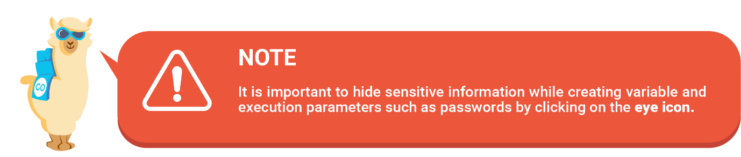

**Create Custom Keyword with Python**

In Copado Robotic Testing, you can also create custom keywords using Python, a high-level general-purpose programming language. Python is one of the widely used programming languages and customizing test case keywords with language that carries simplified syntax makes it more accessible for you. This is why it is recommended to create keywords with Python.

Moreover, with Python, you can utilize any QWords or even functions that are part of selenium.

It’s advisable to store all Python source files in libraries or libs folders when you structure your project. Any python file can be imported as any other Robot Framework library and by default, all methods defined in a file will be exposed as keywords.

For the purpose of having an understanding of developing keywords with Python on a beginner’s level, we will create a Python keyword that prints "Hello from custom Python keyword" to the result log. Let’s follow through with the given steps.

1. Navigate to your **QEditor**.

2. Create a python file**my_custom_library.py** under the libraries folder.

3. Create the following content to the newly created Python file.

from robot.api import logger

class my_custom_library():

    def print_message(self, message):

        """Prints a custom message to log

        """

[logger.info](https://logger.info/)(message)

4. Import your new library in your test suite or resource fileLibrary      ../libraries/my_custom_library.py

5. Call the keyword in your test casePrint message   Hello from custom Python keyword

Well done! 😀 You have created a keyword “Print message” that reflects and triggers the argument - Hello from a custom Python keyword. Now, if you want you can use any Selenium properties and functions to interact with it. However, for that, you need to have a web driver instance.

Done!

**Configuring Test Case Behaviour**

Apart from setting up all-new keywords, you can also change the internal behavior of the test cases in Copado Robotic Testing with **SetConfig QWord**. Changes done with SetConfig will apply globally, that means, once the setting is changed it’s in use for all test cases/keywords until modified again. The basic syntax of using SetConfig is -

**SetConfig      [NAME_OF_THE_SETTING]       [NEW_VALUE_FOR_THE_SETTING]**

SetConfig can be structured for Web, Mobile and Vision. However, for each domain, its function could be different. For web automation, SetConfig is used to configure parameters to a given value in which it returns the previous value as well. For mobile automation, the SetConfig is used to change the value of an existing setting. For computer vision automation, SetConfig is used to organize a configuration value.

Though there are plenty of settings and configuration options that can be addressed through SetConfig QWord, the most common examples of settings you might want to change are:

* Changing timeouts
* Highlighting elements
* Action after typing text

**SetConfig Parameters**

|  |  |
| --- | --- |
| **Setting** | **Description** |
| BlindReturn | Return any value (even empty) from the input element without waiting. Default = false |
| CaseInsensitive | Set containing_text_match according to selected case sensitivity. |
| CheckInputValue | Check that the real value matches the preferred value after TypeText. |
| ClearKey | Set key to be pressed before text is written to the input field. |
| ClickToFocus | Click the Input element before typing. |
| CssSelectors | Use CSS selectors for finding elements. |
| DefaultDocument | Switches to the default frame automatically. |
| DefaultTimeout | Set default timeout for QWeb keywords. |
| Delay | Set delay for QWord. This is meant to be used for demo purposes only and is not a recommended way to control execution flow. Default = 0s (No delays before execution). |
| HandleAlerts | Option for handling alerts boxes, on by default. |
| InputHandler | Check input field status before writing. |
| InViewport | If InViewport is set to true every element outside of the current viewport is considered invisible. |
| LineBreak | Set the key to be pressed after the text is written to the input field. |
| OffsetCheck | Element with no offset is considered invisible by default. To bypass this check, set OffsetCheck to false. |
| RetryInterval | Set default interval for QWeb retry keywords. |
| ScreenshotType | Defines how the screenshot is taken. Default is a normal screenshot. “HTML” saves the page as an HTML frame in the test log. “all” saves both images and HTML pages. |
| SearchDirection | Set search direction for element search. |
| SearchMode | Highlights found elements. |
| SearchStrategy | Sets a search strategy for element search. |
| Visibility | Include/exclude hidden elements from the search. |
| WindowFind | When WindowFind is used VerifyText is not looking for texts for a dom, but simulates CTRL+F like search to find if text exists. |
| WindowSize | Set window size. |
| XHRTimeout | Set default timeout for XHR (How to log we wait for the page to be loaded). |

**Introduction to QConnect**

Besides cloud-based testing, Copado Robotic Testing solution also leverages you with setting up and managing end-to-end aspects of the testing infrastructure on your system through QConnect.

The best way to understand the QConnect is - an extension installed in your system that will ready your environment to run test cases on your local machines. In other words, QConnect is an external tool that is required to automate a proprietary application through Copado Robotic Testing. It can not be installed in the cloud. If you want to use services on a private network that can’t be exposed by other means, you need to download the QConnect extension.

While performing on-premise testing via Copado Robotic Testing, you need to select QConnect as a Run Environment type during Robot configuration.

**Create an Agent**

Before you get into learning how to use QConnect for on-premise testing, attaining knowledge about agents and how to create one is imperative as this is the first thing you should be doing in the process of connecting QConnect.

QConnect Agent is the digital connector that establishes a link between the Copado Robotic Testing platform and QConnect and ready both of them for the test execution. The agent creates a connection-token, also known as an authorization string, that needs to be put into the QConnect installed program.

Therefore, when it comes to carrying out on-premise testing via QConnect, an agent is something that is foremost.

Let’s take a glance at the steps involved in creating an agent.

1. Go to your **Organization** page.
2. Navigate to the bottom right corner to spot the **QConnect** with Agents option.

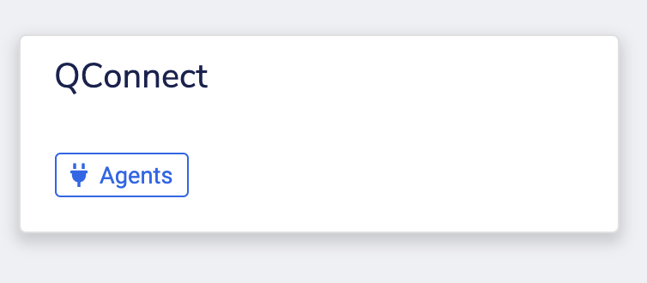

1. Click on the**Agents**. You will now be redirected to the Agents page.
2. Now click on the **+** icon to add a new agent.

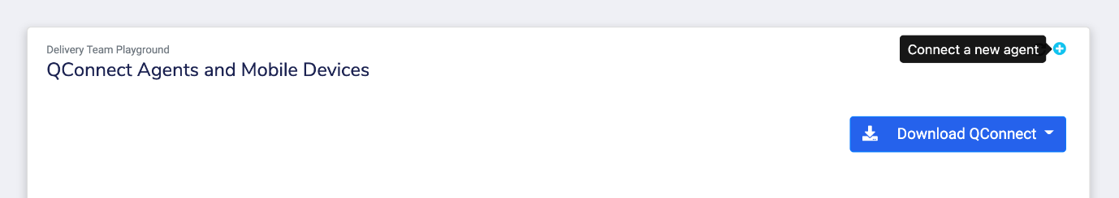

1. Once you are done filling **Agent Name** and **Agent Description**, an authorization string will be generated.

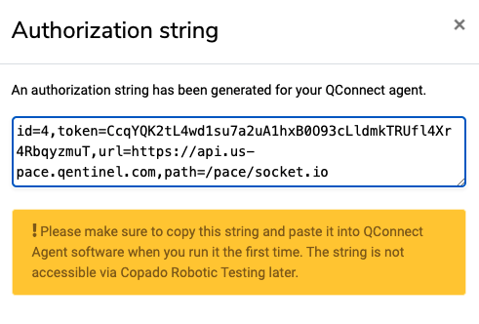

1. Copy it and store it securely, it will be needed when setting up a connection with **QConnect**.

Well done! 😀 Your new agent is ready. You can further customize it by giving your agents additional capabilities and setting up demands as per the project requirements. You will learn about adding capabilities and demand set up in the next topic.

**Understand Agent Capabilities and Demands**

When Copado Robotic Testing starts a test run with a QConnect-enabled robot, it chooses any available agent from the organization by default. To control this behavior, you need to specify agent capabilities, which are named properties of the agent. Also, you need to set demands for the robot you have created stating that only agents with specific capabilities can run the tests under that robot.

* **Agent Capabilities:**Agent capabilities can be added while creating an agent, however, you can also do it later. All you need to do is to look up your agent and click on edit, there you will see the option of **Manage Capabilities**. Now, click on Add Capability. Give your capability a name and the value. That’s it.

* **Robot Demands:** Robot demands are directly linked to the capabilities. Basically, when you want your robot to say that agents configured with certain capabilities need to run the test, you set up demand. In this way, an agent only starts running a test suite if it fulfills all demands of the robot. To set demands, go to the Robots and click the Demands icon under a robot. Now, give the Name/Key and Value of a capability that the agent was created with. Your demand has been adjusted for your agent.

﻿

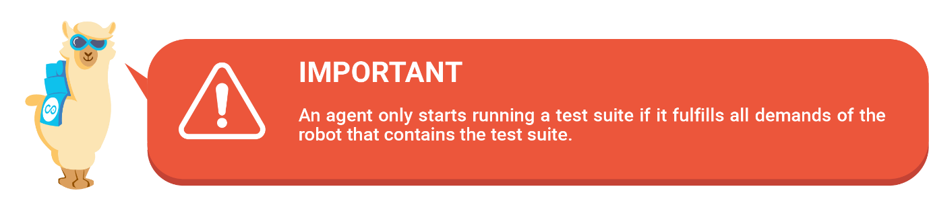

**Finalize Setting Up On Premise Testing Environment**

As you are ready with your agent and have set up capabilities and robot demands, it is time to structure an on-premise test environment with QConnect. Here are the steps you should be following if you want to connect a Copado Robotic Testing robot to an on-premise execution machine.

1. Go to your organization and click on **Agents**.
2. After that, you will need to download the **QConnect**. Choose between Docker, Windows, or Mac as per your system preference.

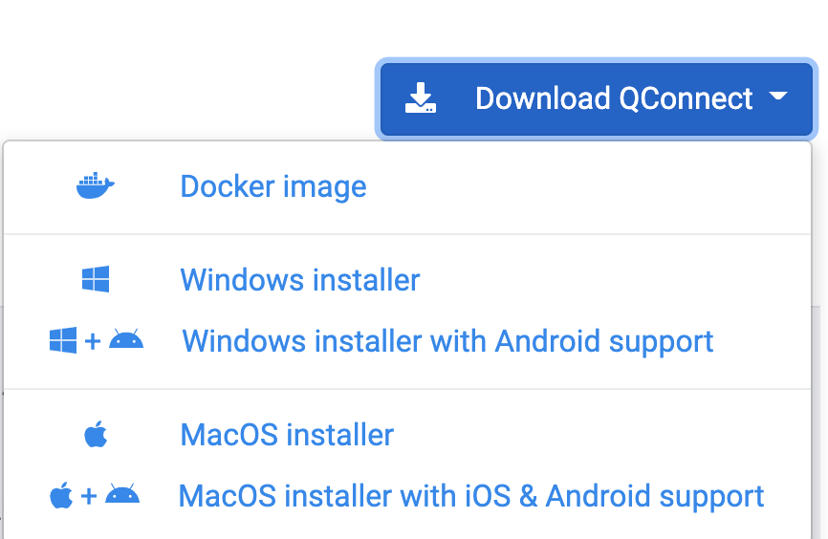

1. Once it is installed, run the **QConnect package** on your system.
2. Now paste the authorization string **connection token** in the QConnect setup window.
3. The next step would be to create a new robot by selecting QConnect as a run environment.
4. Add demands to your **Robot**.

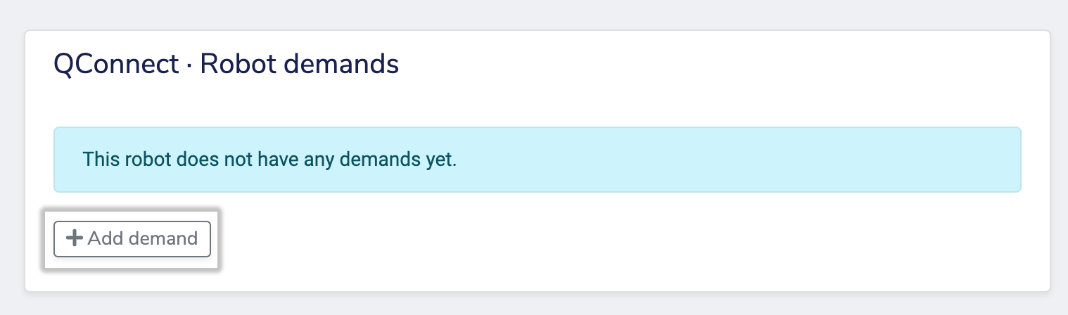

1. At last, create a **suite** and run your test cases.

QConnect allows you to manage test suites and test results which is almost identical to what you have been doing with Copado Robotic Testing’s cloud-based procedure, but the test steps will be executed locally by the QConnect agent that the user has installed.

That’s the only difference between carrying out cloud-based and on-premise testing via CRT.

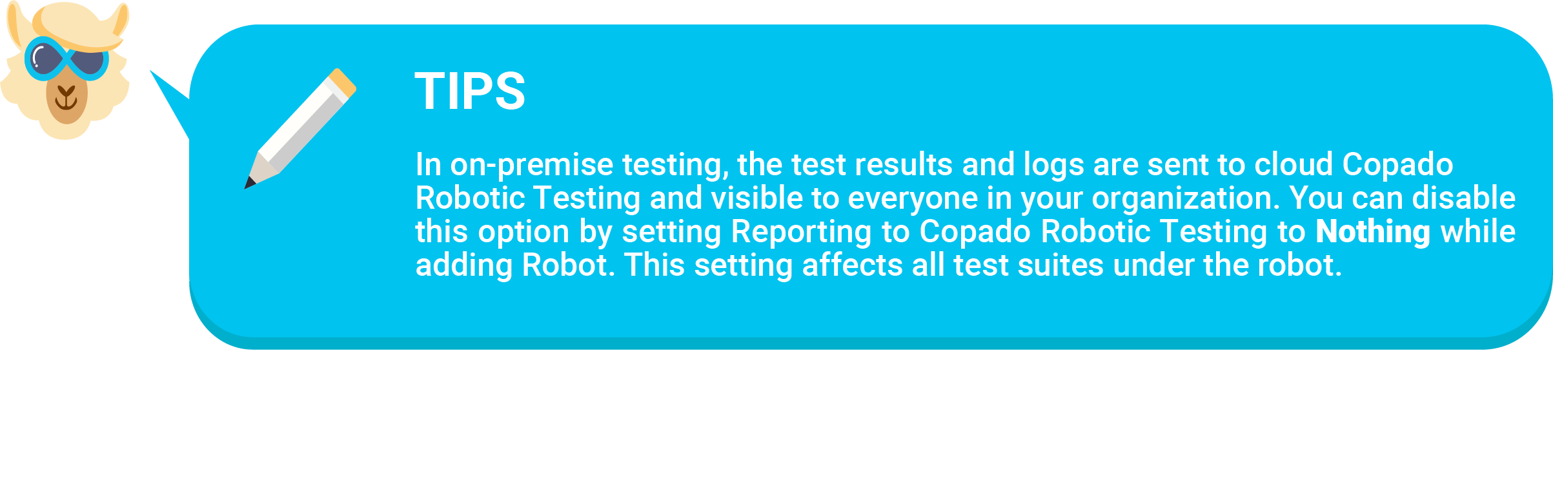

Done!

**Overview**

Creating and automating effective test cases is one of the crucial yet most overlooked parts of test automation. The test conditions are different for each business requirement and thus defining steps for each of them could not be synchronized in the same stream. This is why test design comes in very handy.

In Copado Robotic Testing, automated test design allows you to configure reusable templates that include common defect scenarios, risk scenarios, and business process scenarios so that they can be used in multiple projects within your organization.

Moreover, test templates empower your test scripts to generate effective test cases. Copado Robotic Testing has two automated test generators - **Test Data Generator**and **Combinatorial Test Generator** that enable you to create on-the-go and predefined test data.

Before having an all-inclusive discussion about the test generators, let’s take a quick look at how to enable test generators and combinatorial testing.

**Enable Test Generation**

Test generation capabilities are not enabled by default. You need to configure the test generation by defining a set tag in your test case.By conditioning a set tag in your script, you have control over which tests you would like to generate test cases from. To initiate the test generator, provide a special tag **testgen** to the test case as demonstrated below.

My test case

[Tags]         testgen

Once you validate the implementation of the test generation in your test script, you have two methods using which you can set target and generation mode for your test case. Let’s have a look at how.

**Set a target number for generated tests**

You can control how many test cases you want to generate for the particular test case by conditioning it with the numtests tag. This directive sets the target number for test generation. Copado Robotic Testing uses this number in optimization.

It is important to note that Copado Robotic Testing will override the target in scenarios where the set target is lower than the absolute minimum number of test cases that need to be generated to meet all the requirements. In the example below, numtests are equal to 50 which means the target number for test gen will be 50.

My test case

[Tags]          testgen         numtests=50



**Set test generation mode**

In this process, you generally instruct your test generator which algorithm to use when generating test cases. The algorithm then eventually determines how different combinations are formed. It is recommended to know a bit about combinatorial testing to get a more solid understanding of different generation modes. We will have a look at two testgen conditions here - **Linear** and **Nwise** to identify the test generation workflow with algorithms better.

* **Linear mode:** This is a default test generation mode that instructs the test generator to disable combinatorial testing and to apply a linear data selection mechanism where the test generator aims to generate a test collection where each test data value is tested at least once. For example, the text below will generate two test cases, one with data combination (John, Johnson) and the second with (Jane, Janeson).

My test case

    [Tags]            testgen             linear

    TypeText       First name        [John, Jane]

    TypeText       Last name        [Johnson, Janeson]

* **Nwise mode:**Nwise option, on the other hand, enables the combinatorial test data generator and it is provided with a numeric argument that defines the number of variables interacting. In the example below pairwise testing is enabled by setting nwise=2. And it will generate four test cases with data combinations (John, Johnson), (John, Janeson), (Jane, Johnson) and (Jane, Janeson).

My test case

    [Tags]             testgen          nwise=2

    TypeText        First name     [John, Jane]

    TypeText        Last name     [Johnson, Janeson]

**Enable Combinatorial Testing**

As the name describes, Combinatorial testing is a testing method where varied parameters with multiple combinations are integrated to perform testing. Combinatorial testing is based on the premise that many errors in software can only arise from the interaction of two or more parameters. Basically, you need to define these interacting parameters.

Let’s say you are working on Salesforce, a CRM system for which you have built a new integration and you would like to test if this integration is working end-to-end faultlessly. The first step is typically to enter the first name in the form. In your automated test case, the test step that you will create using QWord will be -

TypeText      First name         John

Now, if you want to generate test cases using combinatorial testing, you would need to provide a data set for the test case. The alternative data values are expressed in the QWords test cases using “list notation” where alternative values are placed between square brackets and separated by commas as you can see below.

TypeText       First name         [John, Jane, Harry, Mary]

The above defines that there are 4 alternative data values for First name, namely John, Jane, Harry and Mary. And in a test case the example below, we will get 6 test cases with data values (John, Johnson, Copado), (Jane, Janeson, Copado), (Jane, Johnson, ACME), (John, Janeson, ACME), (John, Janeson, Inc Incorporated) and (Jane, Johnson, Inc Incorporated).

My test case

    [Tags]          testgen              nwise=2

    TypeText     First name         [John, Jane]

    TypeText     Last name         [Johnson, Janeson]

    TypeText     Company          [Copado, ACME, Inc Incorporated]

**Test Data Generation for Modifiers**

As you have understood how test data generation can be helpful in producing expected results for given inputs. Now we will have a look through how test data generation can be enabled for test cases executed from Copado Robotic Testing and how it can be used to deploy a systematic analysis approach for naturally identifying and generating test cases for covering “corner cases” of various types of data.

Test data generation has an algorithmic approach that is used by supplying QWords with predefined test data modifiers. For a better understanding, let’s create a test case that accepts all valid email addresses and shows a message ‘Valid email address provided’. Your final test case will look as shown below.

My test case

    [Tags]                 testgen

    TypeText            Email    VALID_EMAIL_ADDRESS

    VerifyText           Valid email address provided

As you can see, we have introduced a predefined test data modifier *VALID_EMAIL_ADDRESS* that instructs the test data generation identifiers to create 100 test cases.

If you observe closely, you will realize that each generated test case contains a valid email address in such a fashion that each distinct test case verifies a unique feature or corner case of the email address pattern.

#### 

#### Commonly used data modifier list

|  |  |
| --- | --- |
| **Modifier** | **Description** |
| VALID_EMAIL_ADDRESS | Generates email addresses |
| INVALID_EMAIL_ADDRESS | Generates invalid email addresses |
| VALID_IBAN | Generates International Bank Account Numbers |
| INVALID_IBAN | Generates invalid International Bank Account Numbers |
| VALID_IP_ADDRESS | Generates valid IPv4 addresses |
| INVALID_IP_ADDRESS | Generates invalid IPv4 addresses |
| VALID_IPv6_ADDRESS | Generates valid IPv6 addresses |
| INVALID_IPv6_ADDRESS | Generates invalid IPv6 addresses |
| VALID_HETU | Generates valid Finnish personal identification numbers (Henkilötunnus in Finnish) |
| INVALID_HETU | Generates invalid Finnish personal identification numbers (Henkilötunnus in Finnish) |
| VALID_CREDIT_CARD | Generates valid credit card numbers |
| INVALID_CREDIT_CARD | Generates invalid credit card numbers |
| VALID_ISBN10 | Generates valid International Standard Book Numbers in ISBN10 format |
| INVALID_ISBN10 | Generates invalid International Standard Book Numbers in ISBN10 format |
| VALID_ISBN13 | Generates valid International Standard Book Numbers in ISBN13 format |
| INVALID_ISBN13 | Generates invalid International Standard Book Numbers in ISBN13 format |
| VALID_YTUNNUS | Generates valid Finnish Business Identify Codes (Y-tunnus in Finnish) |
| INVALID_YTUNNUS | Generates invalid Finnish Business Identify Codes (Y-tunnus in Finnish) |
| VALID_ALV_NUMERO | Generates valid Finnish Value Added Tax identification number or VAT identification number (ALV-numero in Finnish) |
| INVALID_ALV_NUMERO | Generates invalid Finnish Value Added Tax identification number or VAT identification number (ALV-numero in Finnish) |
| VALID_VIITENUMERO | Generates valid Reference Numbers (Viitenumero in Finnish) |
| INVALID_VIITENUMERO | Generates invalid Reference Numbers (Viitenumero in Finnish) |

**Combinatorial Test Data Generation and Reports**

**Combinatorial Testing + Test Data Generation = Combinatorial Test Data Generation.**

Let’s suppose you want to create a test case with a predefined test data modifier and along with that, you want to define two or more parameters so that you can obtain multiple sets of data values. You can do that by using combinatorial testing and test data generation in conjunction.

With the Combinatorial Test Data Generation algorithm, you can empower your test script to explore a whole new potential data combinations environment to test your application against. Have a look at the example below.

Here, we have used Nwise generator mode to define a number of variables that the Test Generator uses. This will generate a maximum of 100 test cases for a combination of first and last names from the given choices, a valid email address, and an invalid IBAN number.

My test case

[Tags]      testgen     nwise=2

TypeText    First name  [John, Jane]

TypeText    Last name  [Johnson, Janeson]

TypeText    Email      VALID_EMAIL_ADDRESS

TypeText    IBAN       INVALID_IBAN

VerifyText   Valid email address but invalid IBAN provided

**Test Generation Reports**

Suppose you have enabled test generation in your test script. Now when you execute your test case by clicking on the **Run** from suite page, Copado Robotic Testing will recognize your Test Generation tag **testgen** and generate test cases according to your definition.

Once your test run is completed, you will be able to see the test generation results in the Suite runs section. You will be able to view the total number of generated test cases along with the steps by clicking on the two-vial icon as you can see in the attached image.

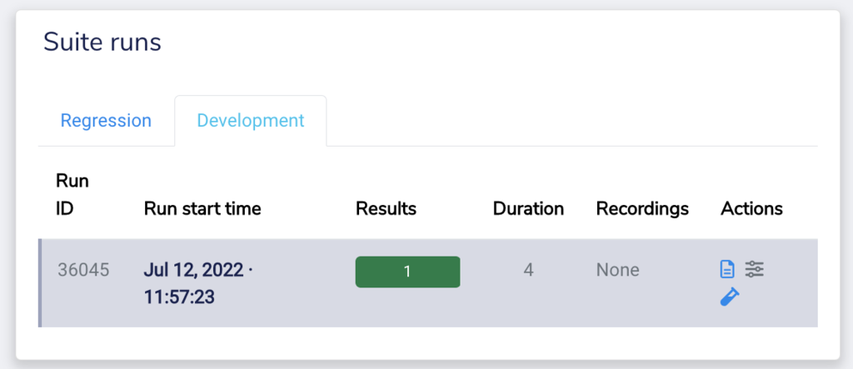

Let’s try to understand this with an easy use case.

Justin, a test engineer working for a SaaS-based company, wants to generate 20 test cases through Copado Robotic Testing. He wants the test generation identifiers to generate tests with different data combinations for the invalid email address of a user named Steve Watson shopping online. Justin has created a test case with certain steps and has now executed the same. This is what the test case looks like.

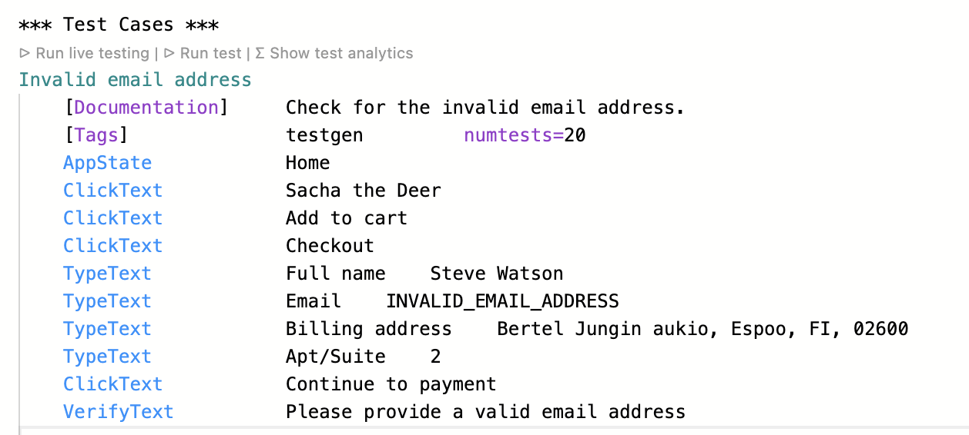

Post completion of the test process, the Copado Robotic Testing generates a comprehensive result for the executed steps. As you can see the system has logged the outcome of the test generation report with 20 different data combinations.

Now, Justin can look through each generated test data and the combination that was put through testing.

**Copado Robotic Testing Advanced Cheat Sheet**

Now you do not have to be worried about making diligent notes while keeping up with your learning because we have taken care of that for you. You can download our cheat sheet file and keep it handy. 😀

[](https://copado.my.salesforce.com/sfc/p/#b0000000YN5R/a/5p0000019yW9/zrdyf7mkB2sdRPSJMzA1_saNn8RxG3veKsD7yus483c)

*Well done! You have reached the end of this module. We hope you had a great time learning about****advanced elements of Copado Robotic Testing****. You can now go ahead and take the quiz to add a new shiny badge 🏅 to your achievements. Good luck!*

**Exam Guidelines for Copado Robotic Testing**

If you click on Next you will be launching the Copado Robotic Testing Certification exam. Before taking the exam, please read carefully the information below:

* To successfully pass the test, it is recommended to have completed all the learning modules included in the Copado Robotic Testing Certification trail.
* The test consists of 20 questions.
* You have 40 minutes to complete the test.
* The passing score is 75%.
* You have 2 attempts to pass the test. If you fail twice, the retake fee is USD 250.00.

More Information about Guidelines can be found in the Copado Robotic Testing Certification Guide: <https://success.copado.com/s/news/copado-robotic-testing-exam-guide-MC64OZDNNAO5BOFC5I5WWQK6LB3U>